No 3 to be online so a teacher can fill out, print and give to each student
South Carolina Academy of Science

Certificate of Merit

In Recognition That

John Doe (Sponsor or student will input the name)

of Hopalong Cassidy School»

Participated in the MESAS Statewide Contest

The above student is recognized for effort toward the advancement of science and math knowledge.

Presented with all the rights, privileges and honors due on this ninth day of May 2022.

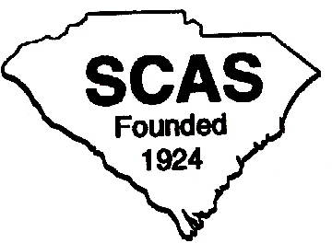

Don Jordan, S C Academy of Science
Executive Director MESAS

