**Digital Measures**

Activity Insight™ Reference Guide



**Digital Measures Activity Insight™ (DMAI) Reference Guide**

**TABLE OF CONTENTS**

**General Program Information 3**

**Security, Backups, Access, & Usage 4**

**Access to Digital Measures 4**

**Suggested Review Schedule 6**

**Key Administrator Contacts 7**

**Main Menu Screen 9**

**Using the System 9**

**Managing Data/Activities 13**

*General*  **13**

*Teaching*  **14**

*Scholarship/Research*  **15**

*Service* **18**

**Report Generation 19**

**DIGITAL MEASURES Activity Insight™**

**(Digital Measures or DMAI for short)**

DMAI is a collection tool that houses information that would normally be included curriculum vitae. The database structure allows these data to be arranged in output documents, including but not limited to vitae, department rosters, or reports required by accrediting bodies.

Many faculty are actively involved in engaging students in a variety of exciting and meaningful ways. It is becoming increasingly important for faculty to document this good work so that it can be appropriately acknowledged in annual activity reports, tenure and promotion documents,

and external reports to our various constituencies. DMAI will allow for this collection of faculty

activities and allow administrators to view summary reports across departments rather than collating information that comes in separately (on paper) from faculty.

The system is operational; however, it may be further modified and customized as needed. This reference guide is meant to assist with data entry for the most commonly used functions. Should you need further assistance, please contact the key administrator for your department or the DMAI Project Coordinator.

**WHAT ARE THE ADVANTAGES?**

1. **24/7 Access**: Faculty can review or enter new data into the database from any computer with an internet connection; eliminate last minute stress of compiling data for annual reports, accreditation, etc.; if activities and accomplishments are recorded regularly throughout the year, reports are just a click away.
2. **Save Time:** Enter data only once and use it to generate different kinds of personal reports/documents (e.g., annual Faculty Activity Reports; curriculum vitae; tenure and promotion documents); import data from Excel and BibTeX formats, Crossref, and PubMed, thus reducing faculty maintenance time; PasteBoard features are available to copy from Word and Excel documents.
3. **Reduce Status Updates**: Instead of continually querying faculty for information about their activities, the department head or dean can use the database to gather the information quickly and generate reports for accreditation bodies, faculty awards received, assessment, program reviews, nominations, etc.
4. **Future modifications** to this database will allow us more easily to identify areas of faculty interest, expertise, and research so that we can better facilitate collaboration, publicize possible funding opportunities, and advocate for additional resources.
5. **No Disappearing Records:** Records do not disappear when personnel changes occur.

**WHO WILL SEE THE INFORMATION?**

Faculty members have access to their own accounts as well as department key administrators, the DMAI Project Coordinator, Department Heads, Deans, and the Provost’s Office.

The system is not open to the public, however, certain fields on the Personal & Contact Information, Awards and Honors, and Professional and Scientific Memberships screens, which are clearly marked with a red “P” for “Public,” are linked to the USC School of Medicine-Greenville website faculty profiles. Only those specific fields will show on the website.

# **SECURITY, BACKUPS, ACCESS, AND USAGE**

Data is stored in a quite complex schema. This setup provides you full access to all of your data at any time, in a simplified view that makes it easier to work with and utilize. The following security measures are in place for Digital Measures servers and datacenters:

* All data are transferred over an SSL-encrypted connection.
* Server rooms are locked, caged, and protected by armed security guards present at all times.
* Servers are firewalled and located behind an intrusion detection system.
* Redundant fire suppression and climate control systems are used at all times.
* Redundant power and Internet connections are enabled.

In addition to these server security measures, Digital Measures also performs secure nightly backups to five geographically dispersed locations. In addition to these backups, you are able to download a full copy of all your data at any time, as often as you like.

**ONCE DATA IS IN THE SYSTEM, HOW WILL IT BE USED?**

The most common and immediate use of the system will be for faculty members to run the Annual Faculty Evaluation Report, annual Candidate Template (Appointment & Promotion Report), and Curriculum Vitae. Reports can be run in Microsoft Word, Excel, Adobe PDF, and HTML (web page) formats and users can adjust the data as needed after downloading it.

USCSOMG will develop other uses for DMAI as the University and Academic Health Center becomes more familiar with the system.

**ACCESS TO DIGITAL MEASURES**

Digital Measures is compatible with Google Chrome, Mozilla Firefox, Apple Safari, and Internet Explorer version 11 or higher browsers. Google Chrome would be first choice. DMAI recommends using the most recent version of these browsers for the best experience. No plug-ins are required. Mobile phone usage is not supported by DMAI.

While Safari 2.0 and greater is supported, it does not support some of the extra functions of the system such as PasteBoard and Rapid Reports. Google Chrome will display all the functions.

Internet Explorer for Mac is not supported, as it has been discontinued by Microsoft.

Faculty can access DMAI from any internet-connected computer at this link:

**www.digitalmeasures.com/login/org-ghs/faculty**. Please bookmark the page for easy access.  Enter your GHS login username, and click the "Need help?" link.  On the "Get Login Help" page, please click on the "Reset Your Password" link in the second sentence and follow the instructions.  Digital Measures will email a password to your GHS email account. When you log in, the system will ask you to change the password.

If you forget your password, click the “Reset Your Password” link on the Login page. Digital Measures will e-mail your password to your GHS e-mail account. Your department’s key administrator or the Digital Measures Project Coordinator can assist you if necessary. Errors regarding “no account found” should be reported to the Digital Measures Project Coordinator.

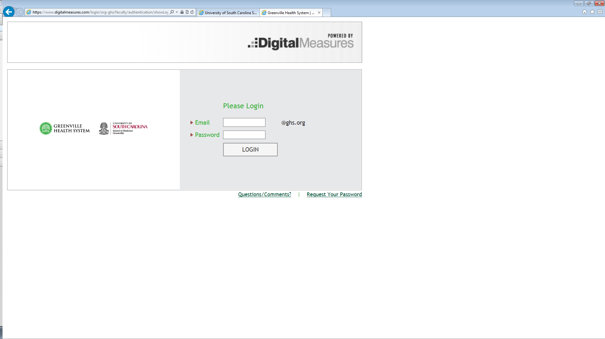

Click this link if you forget your password. DMAI will e-mail a password to your GHS e-mail account.

Login with your GHS username and password provided in an e-mail from Digital Measures in your GHS e-mail account.

When you log in for the first time, you will be asked to change your password.

Sign in with the username and password provided in an e-mail message from Digital Measures in your GHS e-mail account.

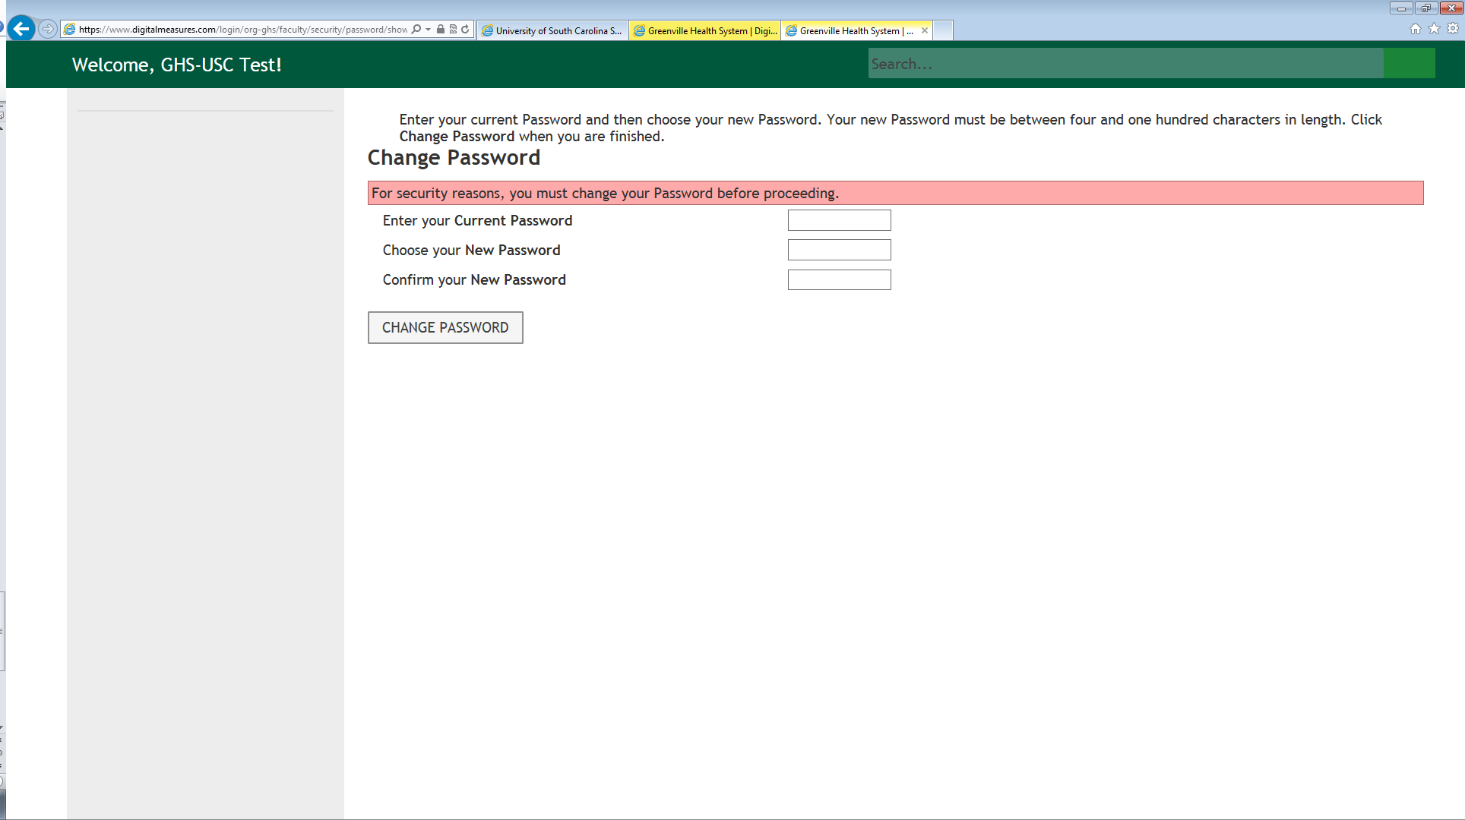

**SUGGESTED REVIEW SCHEDULE**

**There are a few times each year to check DMAI.**

**New Hire**

* **Test your login**: You will use your username and password to log on to your

computer.

* **Review/complete information already entered** for you. You may review information by (1) reviewing data in each screen under Manage Your Activities menu or (2) generating existing reports using Run Reports.

**Beginning of Each Year**

* **Administrative Data**: Confirm accuracy of data appearing on the Personal Contact

Information, Awards and Honors, and Professional & Scientific Memberships screens as

this information populates your web profile.

* **General Service**: Add new or remove expiring service commitments for the year.
* **Other Screens**: Adjust as needed for known changes.

**Ongoing**

Enter activities such as publications, presentations, awards and other activities as they

occur.

**End of Each Semester**

**Verify teaching records:** DMAI provides screens that record information about the

courses you teach. This is important for accreditation and annual reporting. Verify

your teaching data each term and add additional information as needed.

Enter clinical teaching on the “GHS or “USCSOMG Clinical Teaching Records” screen.

Medical school teaching is imported from the OASIS system and recorded in the “Scheduled Teaching Records” screen. Please verify your teaching records there and report any discrepancies to your lead administrator for DMAI.

Also verify the information recorded in the “Academic Advising,” “Academic Mentoring,” “Directed Student Learning,” and “Program Development & Non-Credit Instruction Taught” screens.





**MAIN MENU SCREEN**

Once you log in, a screen similar to this one will appear. Depending upon the account’s user permissions, you will see either “**Manage Data”** or **“Manage Activities.”** As you navigate through other sections of the site, you can return to the main menu by clicking “**Manage Data (or Activities)”** on the left sidebar.

Use this link to return to the main menu from any section of the site.

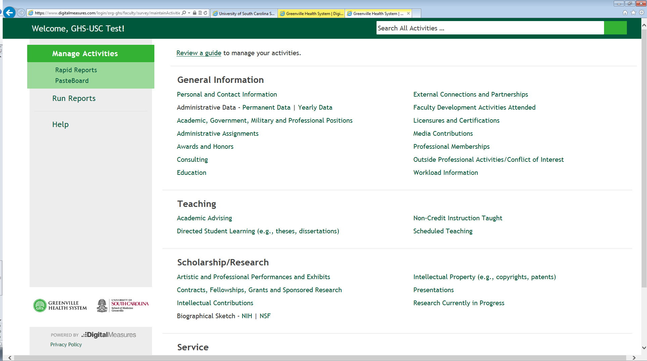

Click here to review DMAI’s Privacy Policy.

View an online guide to DMAI.

This link contacts the DMAI technical team to assist with technical difficulties in using the site.

Select the area you wish to edit or add by clicking on its title.

**Session Time Out**: Users who log in to DMAI will automatically be logged out after 90 minutes of inactivity. Prior to being logged out, the user will be presented with a warning through which they can refresh their session if they are still working. This warning prompt appears 5 minutes before the session is set to log the user out. This step is taken to protect the security of the user’s account.

**USING THE SYSTEM**

**Adding New Items**

When entering your data, you may notice that most of the screens will have an option that says “Add a New Item.” Choose this button to enter your data. If you would like to delete an item, click on the trash can icon. If you choose to delete a record, you will be prompted about your decision. DMAI allows you to save partial records and data; for this function, use the “Save” option. Be sure to save work before leaving the screen; otherwise, it will not be saved.

**Copying, Cutting, and Pasting Information**

It is always an option to use the Copy, Cut, and Paste functions on your computer and even the Snipping Tool to cut and paste from documents into DMAI. The DMAI system itself also has a PasteBoard function that may prove useful to you.

To use DMAI’s PasteBoard utility, copy text from another document into the PasteBoard utility in the upper left menu, then drag-and-drop or paste it into data fields. Resize the PasteBoard or move it to another position on the screen as needed.

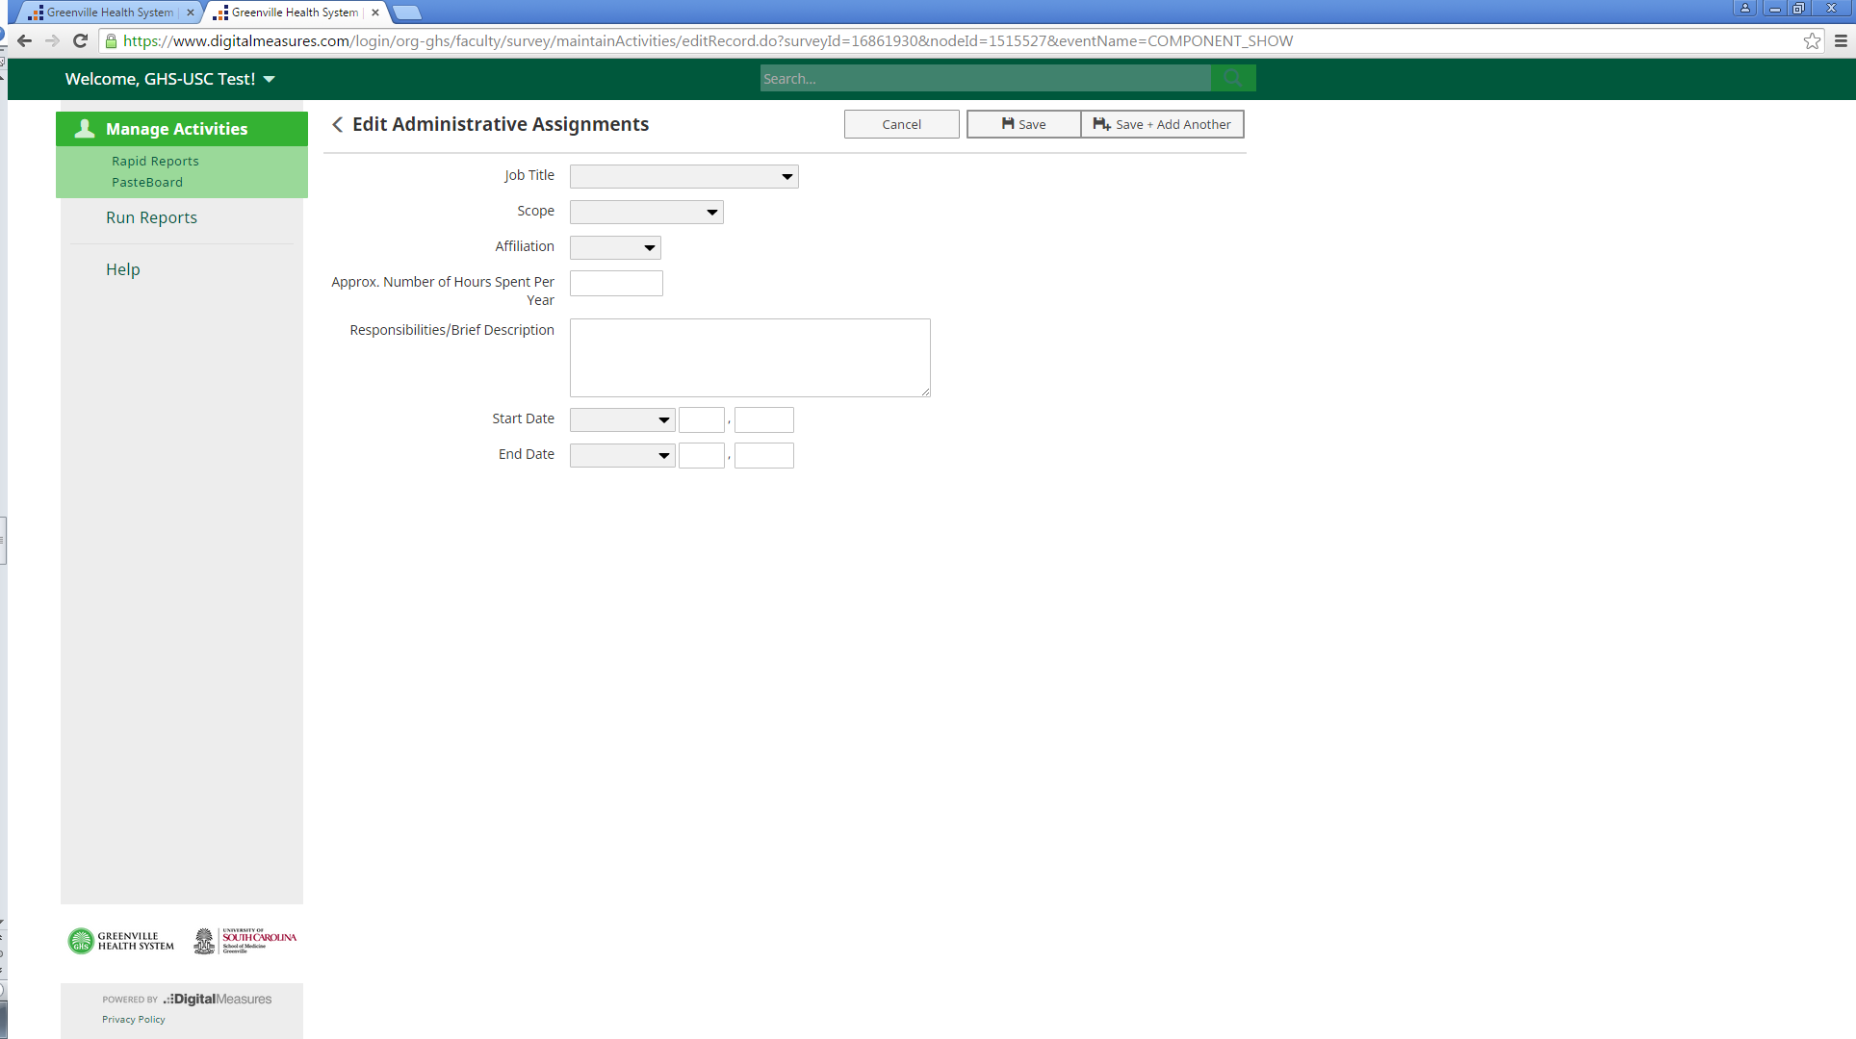

Use the PasteBoard utility to cut and paste information from other documents.

“Save” and “Save and Add Another Record” by clicking here.

Cancel entry here. DaData DataData

**“Save,” “Save and Add Another,” “Cancel” Buttons**

When you have completed a form, you have two options to save your data. You must click either “Save” or “Save and Add Another.” If you click on the “Save” button, ***your data will be saved*** and you will be returned to the “Add Item” screen. If you click on the “Save and Add Another” button, your information will be saved and the form will clear for input of another item. “Cancel” will take you to the “Add a New Item” screen if you are entering a record or the Main Menu if you are filling out a form. The “Cancel” option ***does not save your data*.**

**Manage Data (or Activities)**

Return to the **“Manage Data (or Activities)”** screen by clicking on and holding the left arrow next to the page heading or by clicking **“Manage Data (or Activities)”** on the menu on the top left side of the screen. You can also return by clicking the browser’s Back button.

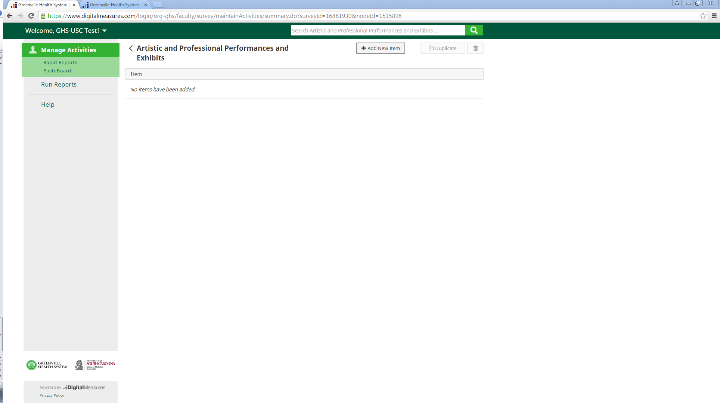

Click and hold the arrow to return to the “Manage Activities” screen or click “Manage Activities” on the menu.

**Drop-Down Menus – Use of “OTHER”**

There are faculty activities which will not fit into existing categories/types. Find the most appropriate category or make use of the “Other” and “Explanation of Other” categories to document this activity.

**Spell-Check**

DMAI does not have a Spell-Check function. An easy way to check your spelling is to open Microsoft Word, type the word or text to be checked into a Word document, click Review in the top menu, then click Spelling and Grammar to use the Spell-Check function there.

**Font/Characters**

You may copy and paste special characters – such as Greek or Latin characters, accent marks or other diacritical marks – into the system from another source as long as they are Unicode-compliant. Unicode is an industry standard set of characters that allows computers to consistently represent and manipulate text expressed in any of the world’s writing systems. Examples of fonts that are Unicode-compliant include Arial and Times New Roman. Examples of fonts that are not Unicode-compliant include Symbol and Wingdings. If characters are not transferring to the system as you expect, try changing their font to Arial or Times New Roman and then copy and paste the text into the system. Of note, changing the font in some applications will convert symbol characters to images, rather than to equivalent characters in the unicode font. Checking the symbols once the font has been updated to confirm they are unicode characters is beneficial before testing copying and pasting these characters into the system.

**Text Entry**

Many screens provide text boxes for data entry. Text boxes generally will allow you to input as many characters as you would like.

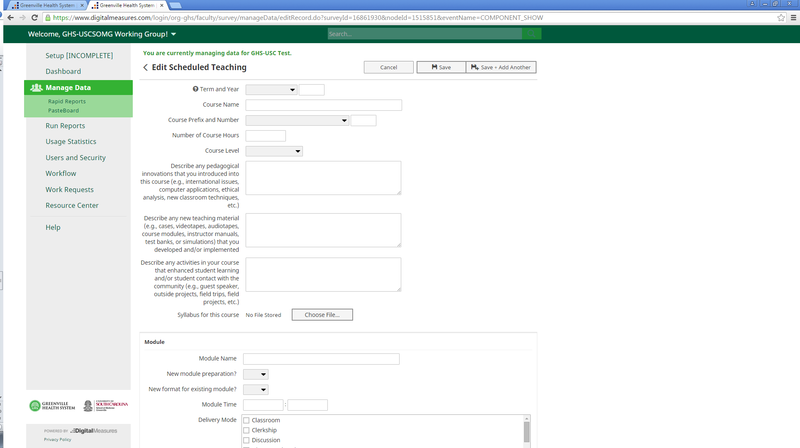

Click on the lines in the corners of text boxes and drag them to increase the size of the boxes as needed.

You may enlarge a text box by clicking on the black lines in the bottom right corner of the text box and dragging them.

**Read-Only Information**

Read-only information,indicated by a small “R” next to the field, is information which has been input for you by an administrator and cannot be edited except by a key administrator or the Project Coordinator. **Personal and Contact Information, Administrative Data – USCSOMG Faculty Rank/Promotion Record and History – USCSOMG Faculty Appointments** in the **General Information section** are areas where Read-Only information is found. Please notify your department’s key administrator or the DMAI Project Coordinator if any changes on these screens are necessary.

Most of the information in the **Course** and **Module** sections of the **Scheduled Teaching Records screen** is Read-Only as well because the information is imported from the OASIS system. If changes are needed in this section, please contact the Course Director, key administrator for the department, or DMAI Project Coordinator.

**Dates**

DMAI reports rely on the dates entered for each activity record. As a rule, you will need to have at least one date, which can be a year, in order to save a record.

* For activities that are/were only on one day, leave the start date blank and specify the end date.
* For activities that you started but have not yet completed, specify the start date and leave the end date blank.

**NOTE**: ***For current position(s), you should leave End Date blank. DMAI assumes***

***a “ - Present” date range when the end date is blank.***

**DATA ENTRY TIPS**

**General Tips**

Faculty can access DMAI from any internet-connected computer at this link:

**https://www.digitalmeasures.com/login/org-ghs/faculty**.

The first time or two that you visit DMAI or work in a new section, take a moment to view the drop-down menus with all choices available on these screens. It will be important to select the correct screen for data entry. ***Do not duplicate information between screens by recording the same instance in two screens.***

***Print a copy of your CV before entering it into the DMAI system. Take time to decide on which DMAI screen you will enter the information and jot down the screen names on your CV. Doing this will save you a lot of time.***

When using Digital Measures, especially initially, focus on entering information that is readily available and leave the rest blank. Fill in other fields later. Leave fields that do not apply blank. This practice will help to speed up the data entry process and minimize frustration.

You will have the option in some sections to add other contributors to your work. If you add another person, you become the primary record holder and will be the only person (in addition to the key administrators and Project Coordinator) who can edit the information in the system.

**Organization of Information**

The options found when selecting “Manage Data (or Activities)” include four general categories of information: **General Information; Teaching; Scholarship/Research;** and **Service.** Some additional information for several of the screens appears below.

**MANAGING DATA/ACTIVITIES**

**General Section**

**Personal and Contact Information (PCI)**

The PCI screen contains several data fields that cannot be edited. These fields represent data

completed during user creation and have a small letter, “R,” which indicates that they are Read-Only fields. Add or revise other data as needed such as Building Where Your Office is Located, Office Phone, Biography, Teaching Interests, etc. If corrections are needed for any of the Read-Only fields, notify your department’s key administrator, who will be able to correct the information.

**Administrative Data--USCSOMG Faculty Rank/Promotion Record**

These data include your starting rank, start date, and information about your faculty rank levels held at the USC School of Medicine Greenville. This information is imported by the DMAI Project Coordinator. If any corrections are needed, please contact your department’s key administrators or the Project Coordinator.

**History—USCSOMG Faculty Appointments**

These data will provide your rank, tenure, and leave information. This data is imported by the DMAI Project Coordinator.

**Awards and Honors**

Update awards and honors received as soon as possible as they are received. The month and year of the award must be reported. Please note that memberships in honorary societies are recorded in the Professional & Scientific Memberships screen.

Honors and awards that include a monetary component may be included here if the honor is most important (e.g.: Fulbright, Nobel). If the monetary component is most important, (e.g.: NSF Young Investigator Award, MacArthur Fellowship), please record the information under Contracts, Fellowships, Grants, and Sponsored Research in the Scholarship/Research category. If you list the award here, please provide a monetary estimate of the research value of your award. For example, salary and travel expenses to pursue research abroad would count while a monetary prize to you that you can spend on anything would not. Elections in a professional society should be listed under the Service screen.

**Consulting**

Add new items as needed to document work in the areas of academic, for-profit organizations, government, litigation, and non-governmental organizations.

**External Connections and Partnerships**

Faculty may input information on external relationships such as speaker, funding, and recruitment activities.

**Faculty Development Activities Attended**

Faculty development activities include any form of activities you have done to acquire additional

knowledge or skills, other than formal coursework related to completion of degrees. Grand Rounds attendance, Continuing Medical Education (CME), and seminars are some examples of activities to include on this screen.

**Licensures and Certifications**

Any licenses, registrations and certifications such as medical licenses and board certifications should be entered on this screen. Advanced Cardiac Life Support (ACLS) and Pediatric Advanced Life Support (PALS) should be listed as certifications here, if applicable.

**Media Contributions**

List those contributions that involved your professional expertise in radio, television, newspaper articles, magazines, blog posts, and the Internet here.

**Professional & Scientific Memberships**

Enter the dates of membership in any professional, scientific, or honorary society here.

*Additional duties beyond simple membership such as serving as officer or committee chair should be reported separately in the Service screen.

**Teaching Section**

**Academic Advising**

Enter general information such as hours spent, levels and numbers of students served, and description here.

**Academic Mentoring (e.g., theses, dissertations)**

Enter information about student interaction such as independent study, dissertation

chair/member, research mentoring, supervised research, etc. as provided in drop-down menu for involvement type. Specific students’ names can be listed on this screen.

**Program Development & Non-Credit Instruction Taught**

This screen should be used for recording any programs or non-credit courses that you have taught or are teaching outside USCSOMG classes. Examples might be professional development courses that you teach.

**Scheduled Teaching Records**

Scheduled Teaching Records: Entries are classes taught in the USC School of Medicine Greenville and are populated periodically by the DMAI Project Coordinator from information on the OASIS system. Once a course appears in this screen, you will be able to review and

information about your preparation time, teaching time, review time, and assessment time. If corrections are needed, contact a key administrator for your department or the Project Coordinator.

**GHS-USCSOMG Clinical Teaching**

This screen is used for recording clinical teaching experiences, such as resident teaching. You or your key administrator will need to enter this data.

**Current & Previous Teaching at Other Institutions**

This screen is to be used only for current and previous teaching at institutions other than GHS and USCSOMG.

**Scholarship/Research Section**

Scholarship and research activities will be collected using the following screens. While only a

few fields are marked as required, complete as much information as possible to

communicate your achievements.

**Contracts, Fellowships, Grants, and Sponsored Research**

Faculty can report all new monetary and in-kind awards received for external awards in this section. It is especially important to list all those awards that occurred outside of the Office of Sponsored Programs, for example, a fellowship awarded directly to you or a sub-contract on an award administered by another institution.

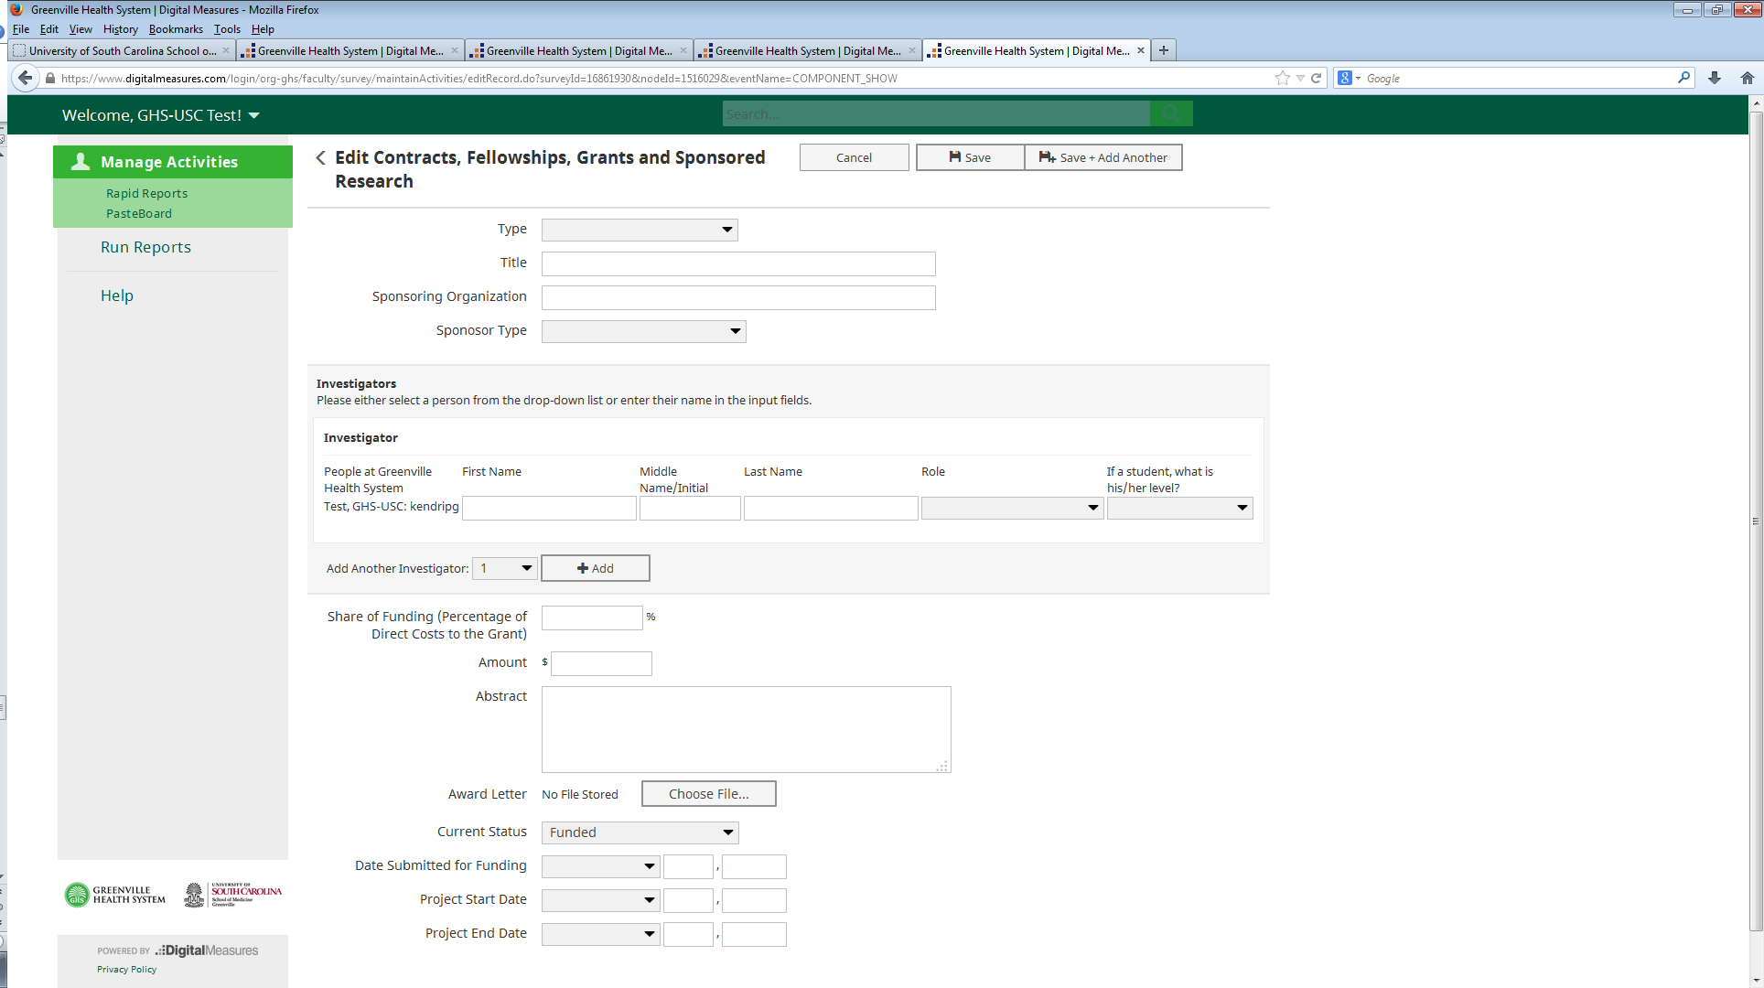

Add collaborators here. ***Note that by adding others, you become the primary record holder and only you, your department’s key administrator, or the DMAI Project Coordinator can edit the record.***

Keep “Current Status” field updated -change from “Currently Under Review: to “Funded” or “Not Funded.”

**Publications & Other Intellectual Contributions**

If you have **publications** to enter, they should be entered in this section. Contributions that should be recorded here include the following: manuscripts, book chapters, abstracts, books, book reviews, broadcast media submissions, conference proceedings, course materials, curricula, instructor’s manuals, journal articles, posters, med-ed portal contributions, newspaper contributions, software, technical reports, and written cases with instructional materials. Other contributions can also be logged here using the “Other” designation and the Explanation of “Other” blank.

You can import them in bulk using the Import utility or you can enter them one by one using the Add a New Item button.

Publications listed on PubMed or Crossref can be imported directly through the PubMed and Crossref import functions. The import function is an easy way to download a large number of publications at once. Be careful to note which publications belong to you, however, since there can be other authors with the same last name and initials.

Publications stored in reference managers or databases, such as EndNote, Google Scholar, Mendeley, RefWorks, Scopus, Web of Science, or Zotero can be imported through the BibTeX import function. A guide to BibTeX imports is located within the “software systems” link in the BibTeX option.

The first row of Authors/Editors/Translators is automatically populated with your user information. If you are not first author, leave your name there and move it to the proper position using the up and down arrows on the right side of the section.

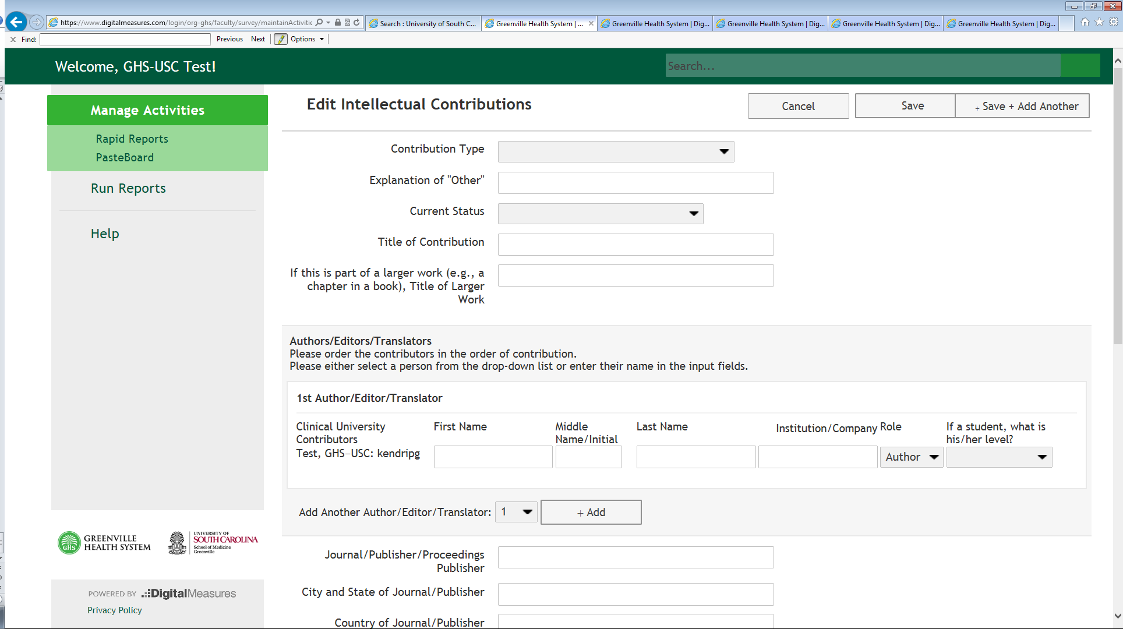

Use this button to add other authors, editors, or translators. Selecting people from USCSOMG adds entry to that person’s record as well, but only you and key administrators can edit it.

Enter authors by order of contribution.

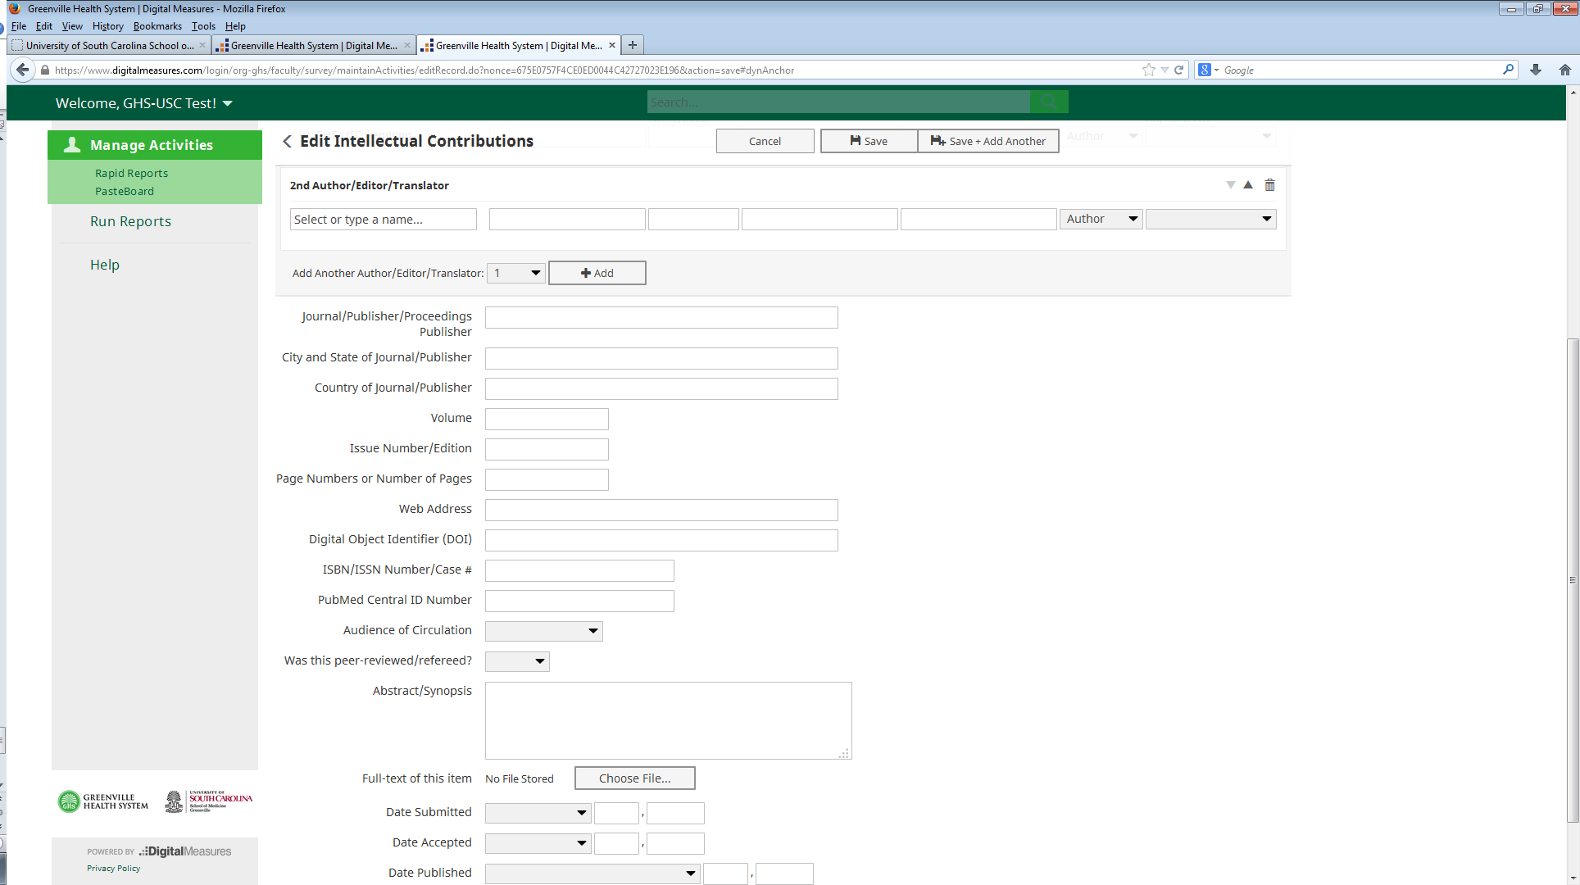

To delete a contributor, click the trash can icon at the top right side of the screen.

Publications must include the following fields:

* **Current Status:** Works in progress, submitted, etc. contributions can be entered here but ***only papers that are******“Published” will show up in reports***. Be sure to keep this attribute current.
* **People:** Your name will display as 1st author by default. Once additional people are added, use up/down arrows to adjust order. Add as many author boxes as applicable using the “Add another Author” button. Multiple boxes can be added at once. As you add people who are in the GHS-USCSOMG Activity Insight system, their records will be populated also with the same information. Whoever inputs the data first becomes the record owner.
* **Dates:** Dates are critical. Screens with dates require at least one date (which can be a year) in order to save the record. Please enter as applicable date fields with month, day and year.

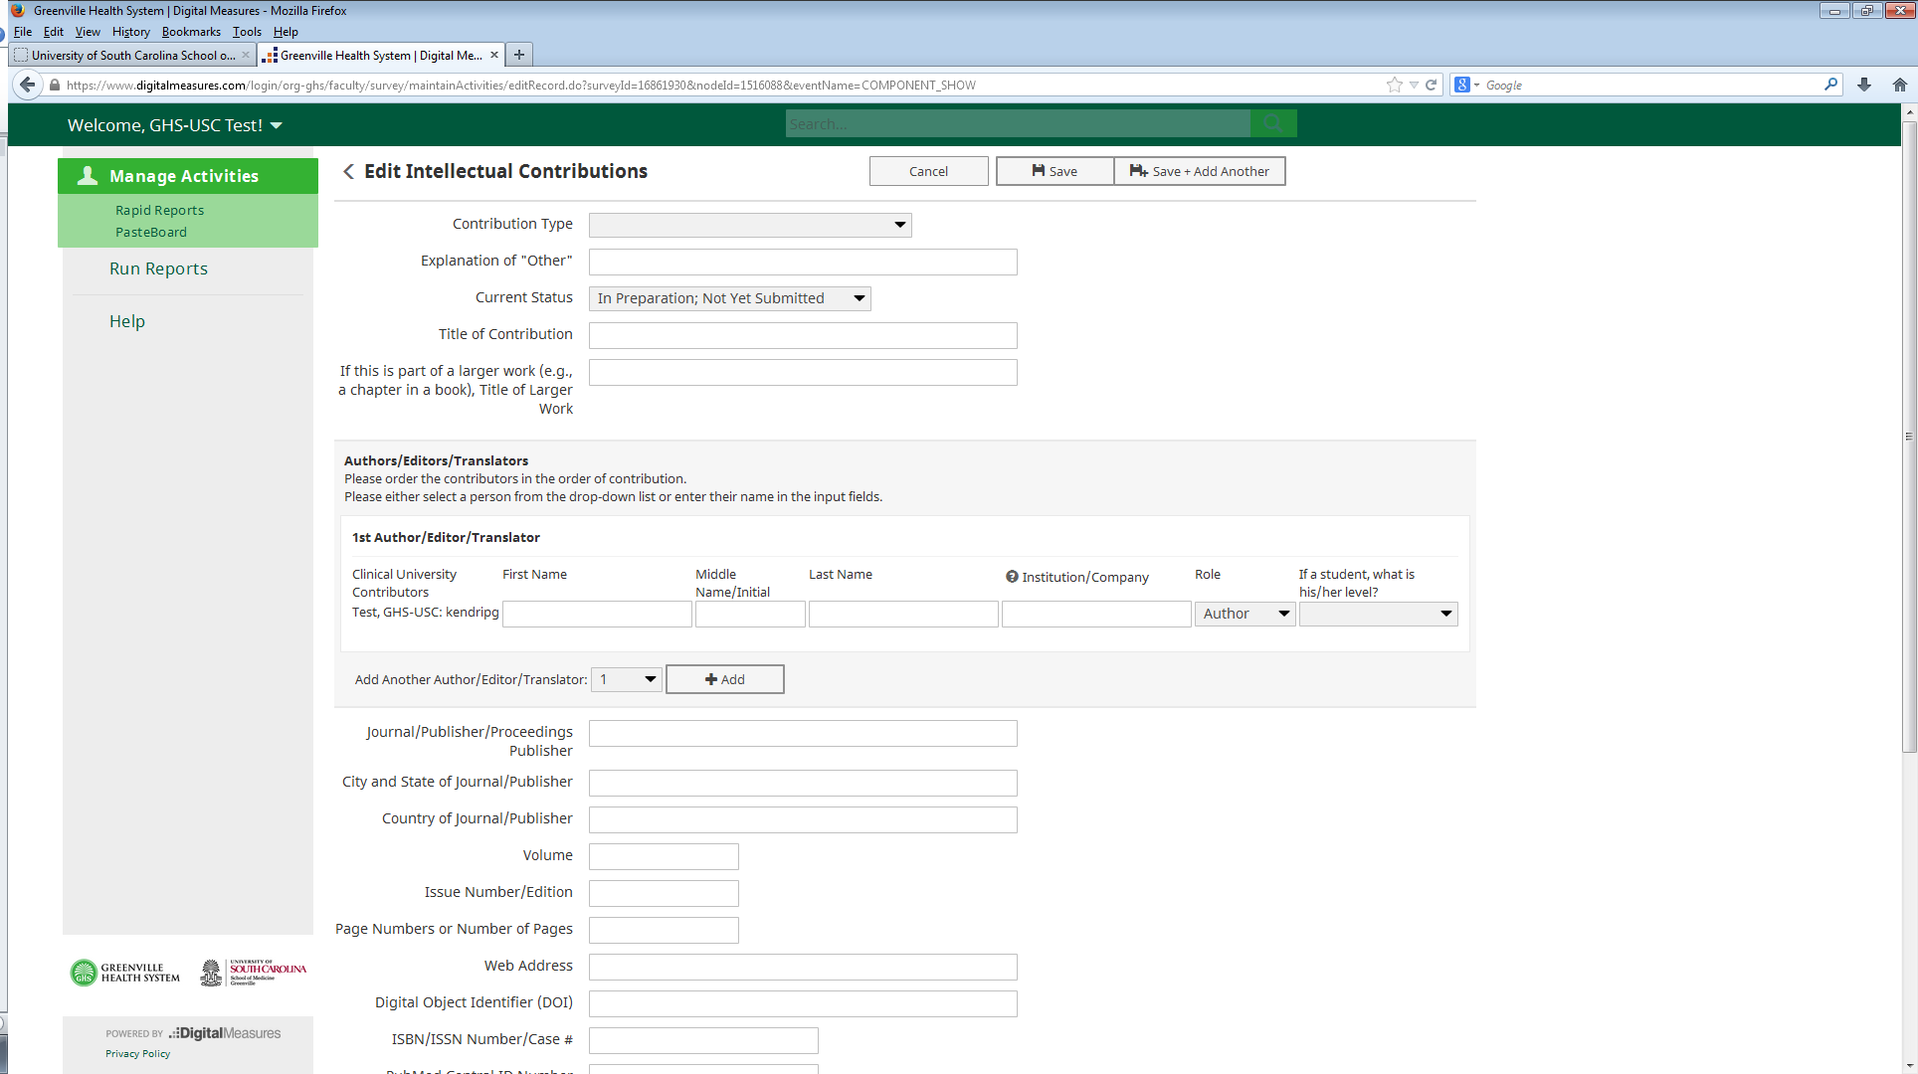

Be sure to keep “Current Status” up-to-date! Only “Published” papers will show up in reports.

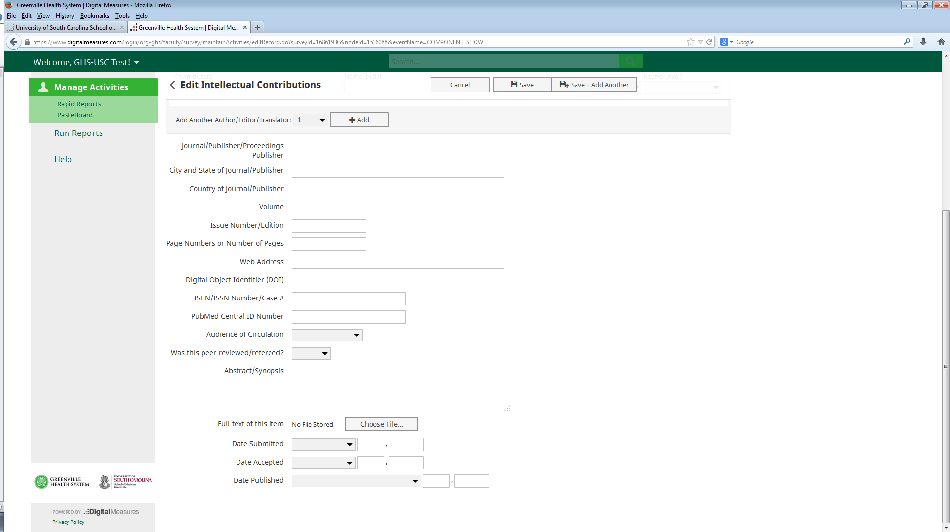

Dates are critical and at least one date (which can be a year) is required to save the record.

**Intellectual Property**

This would include all protected works not listed above. Examples would be inventions whether

patented or not, trademarks, and copyrighted materials such as computer programs.

**Presentations/Programs/Lectures/Workshops**

This would include all talks, posters, and other presentations made to an audience of your

professional peers. Please include the date, location, and event. Presentations given on multiple occasions can be entered by “copying” the first entry then editing the data and location. If “Other” is selected as presentation type, please complete Explanation of Other. Location of presentation should be used to document city and state. Please use the two letter for the state, e.g. “SC” for South Carolina.

**Scholarly Research**

Use this screen to enter scholarly research which receives internal funding or no funding. Research that is underway in stages of planning, on-going, or writing results or other scholarly research can be recorded here.

**Service Section**

**General Service**

The General Service screen allows faculty to document service in the department, Greenville Health System, university, professional and public areas. Work as a committee member or in a leadership role for a committee is recorded here.

Uncompensated or nominally compensated service should be included here. Paid service should be appropriately documented in the screen for Current & Previous Employment (including GHS or USCSOMG Teaching Positions, Military Experience, & Hospital Privileges).

While it is appropriate to include offices held with professional organizations, membership in such organizations should be documented under the Professional & Scientific Memberships screen.

**REPORT GENERATION**

**Faculty** have access to these reports – Curriculum Vitae, Candidate Template (Appointment & Promotion), EVU Data (Ob-gyn Department), NIH and NSF Biographical Sketches, and Scholarly Activities & Intellectual Contributions by Contribution Type.

**Department administrators** have access to the following reports--Academic Degrees Earned; Annual Faculty Evaluation Document—Biomedical Sciences; Awards and Honors; Birthday Report by Month; Candidate Template (Appointment & Promotion Report); Contracts, Grants and Sponsored Research by Faculty; Curriculum Vitae (CV) – Biomedical Sciences/Academic; Curriculum Vitae (CV) – Clinical; Editorial and Review Activities by Faculty; EVU Data; Faculty Directory; General Service by Faculty; Intellectual Contributions by Faculty; NIH Biosketch; NSF Biosketch; Outside Professional Activities/Conflict of Interest; Scholarly Activities & Intellectual Contribution by Contribution Type, and Scholarly Activities & Intellectual Contributions by Faculty Member.

There are three ways to get reports from the system and these are described below.

*Please note that all reports should be reviewed and may need to be edited. The default report format is Microsoft Word. Editing a report will allow you to add any information which may be missing, incomplete, or incorrect. You will also want to pay attention to how the document is spaced, especially at the top and bottom of each page. Just make your changes in Word format on the report itself and save it on your computer. Information in your profile may need to changed, added, or adjusted in order to make certain reports come out correctly.*

**I. For individual reports (just for yourself),** select “Rapid Reports” from the left sidebar menu.

**Step 1:** Select desired report from the drop-down list then click on the “Select Report”.

**Step 2:** Select the date range. The “Start Date” should be the date of the earliest information

you want to appear on your report.

**Step 3:** Select report format (Microsoft Word, Excel, Adobe PDF, or HTML). Downloading a document as a Microsoft Word document facilitates editing of any empty field, deleting unwanted data, or changing layout.

**Any information that you type directly into the Microsoft Word or Excel document will NOT be saved in the Digital Measures system. You will need to save the Word document like a normal document and keep a copy for your records.**

**Step 4:** Click the “Run Report” button. Your report will pop up in the left corner of the screen. Open, rename, and save the document on your computer. **Please review your document and make any necessary changes, then save it on your computer.** Make sure the margins and spacing, especially at the top and bottom of each page, is how you want it to be. Any information that needs to be added or removed from the report can be done at this time.

**II. Custom reports** for topics not covered in the standard reports list are available by clicking on the “Run Report” option on the left hand menu.

**Step 1:** Select the “Create a new report” option at the bottom of the report drop-down, as

shown here.

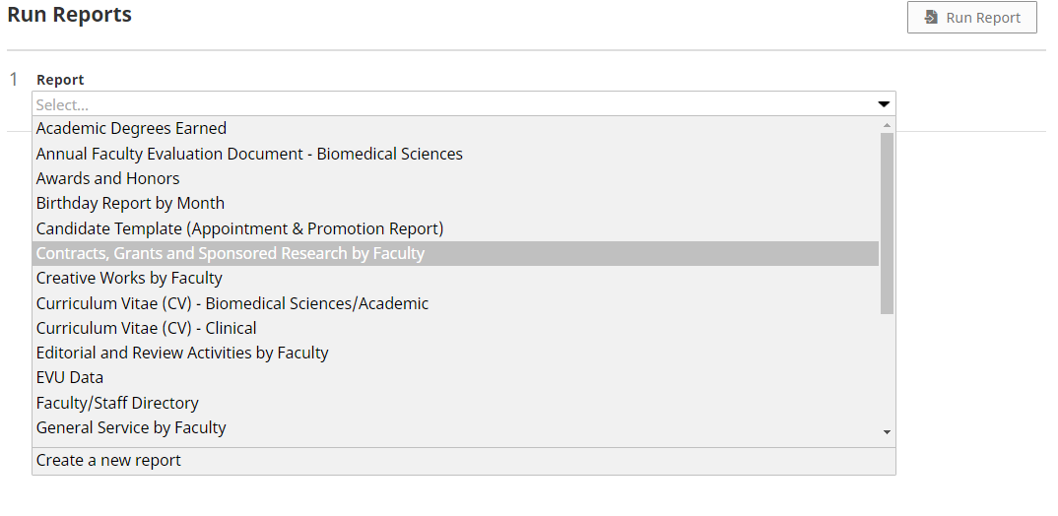

**Select this option.**

**Step 2:** Select the date range. The ‘Start Date” should be the date of the earliest information

you want to appear on your report. **Remember – activities with no dates will always**

**appear regardless of date range selected.**

**Step 3:** Select “Whom to Include” by clicking the Change Selection link, as shown here.

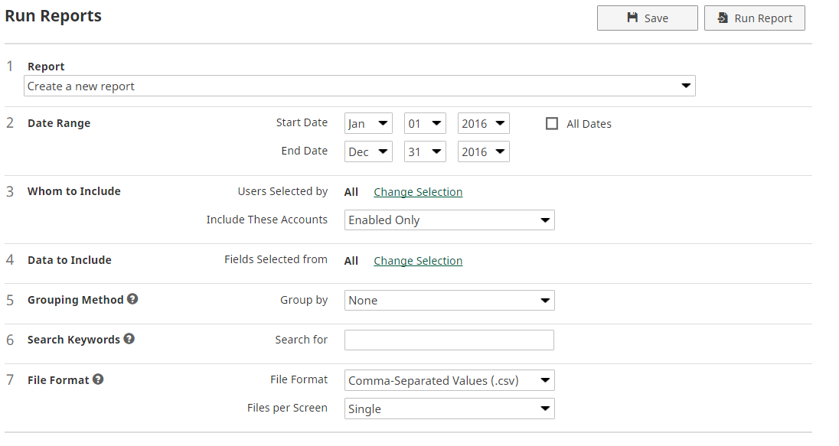

**Select this option.**

**Note that there is an option here to include “Enabled Accounts,” “Disabled**

**Accounts,” and “Enabled and Disabled Accounts.”** The “Enabled Accounts” are

current user accounts. “Disabled Accounts” are user accounts whose records are needed

for the organization, but the users no longer work here. At this time, the only Disabled

records in our system are Course Directors’ accounts for people who no longer work

here.

When you click “Change Selection,” the following box will pop up with several options.

Select the individuals or groups to include and click “Save.”

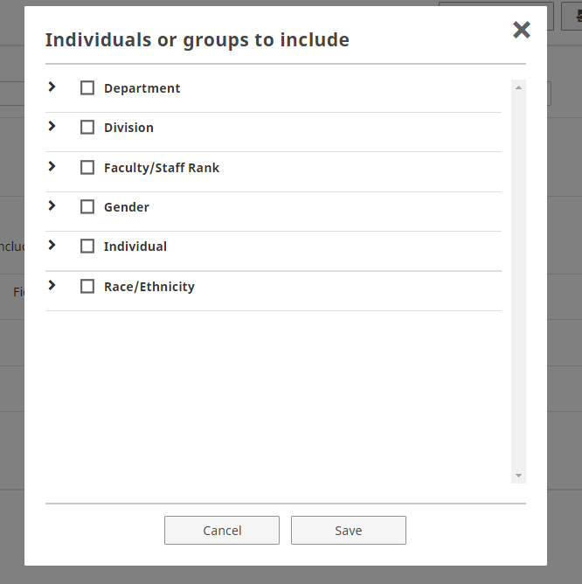

**Step 4:** Select “Data to Include” by clicking on the green “Change Selection” link here.



**Select this option.**



**Select this option.**

**Step 5:** Select “Grouping Method” by clicking on the arrow on the right side of the drop-down box. Help information is available by clicking on the circle with the “?” in it.

**Step 6:** Select any keywords to create a special report. For example, if you would like a report on Continuing Medical Education courses taken during a certain time frame, put “Continuing Medical Education” or “CME” in the keywords field. See the Help information by clicking on the circle containing the question mark. First try to run the report that you want WITHOUT keywords, then run it again with keywords if the report does not come out as desired. The more restrictive the parameters, the less information the report will produce.

**Step 7:** Select “File Format” by clicking on the arrow on the right side of the drop-down box. Formats available are: Comma-Separated Values (.csv), Word, PDF, and HTML. Help information is available by clicking the question mark in the circle.

**Step 8:** Click the “Run Report” button in the upper right area of the screen.

The report pops up in the specified format in the left corner of your screen. Left-click on the report once and the document will open. Rename and save this document on your computer to continue to have access to it. You will need to edit the document, paying attention to upper and lower margins as well as any text that “hangs” at the bottom or top of the pages. You can also add or delete any information and save the document in that format on your computer.

**Any information that you type directly into the report document will NOT be saved in the Digital Measures system. You will need to save the document as you would any document and keep a copy for your records.**

III. **For department reports or reports including multiple people,** click the “Run Report” option.

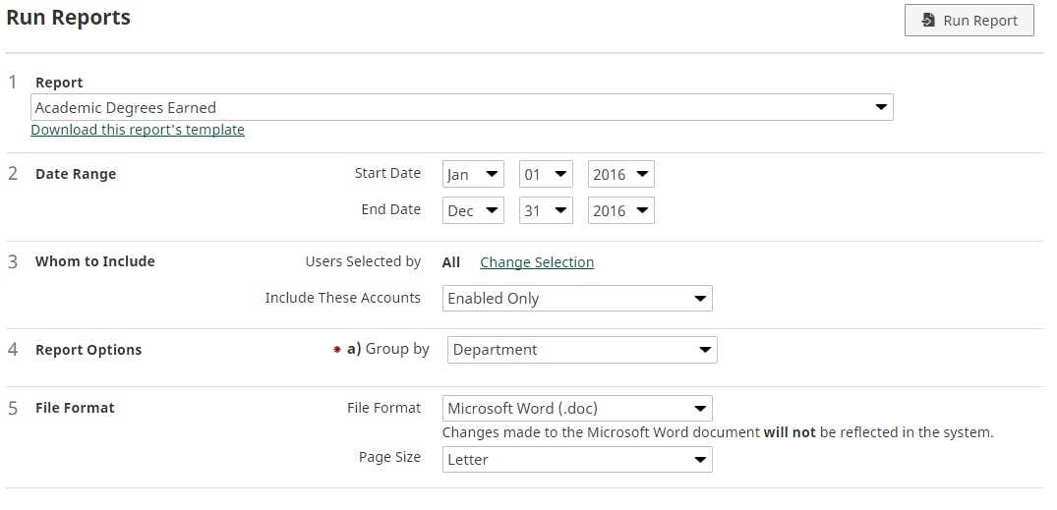

**Select these options.**

**Step 1:** Select desired report from the drop-down list.

**Step 2:** Select the date range. The ‘Start Date” should be the date of the earliest information

you want to appear on your report. **Remember – activities with no dates will always**

**appear regardless of date range selected.**

**Step 3:** Select “Whom to Include” by clicking the Change Selection link.

**Note that there is an option here to include “Enabled Accounts,” “Disabled**

**Accounts,” and “Enabled and Disabled Accounts.”** The “Enabled Accounts” are

current user accounts. “Disabled Accounts” are user accounts whose records are needed

for the organization, but the users no longer work here. At this time, the only Disabled

records in our system are Course Directors’ accounts for people who no longer work

here.

When you click “Change Selection,” the following box will pop up with several options.

Select the individuals or groups to include and click “Save.”



**Step 4:** Select “Data to Include” by clicking on the green “Change Selection” link here.



**Select this option.**

**Step 5:** Select “Grouping Method” by clicking on the arrow on the right side of the drop-down box. Help information is available by clicking on the circle containing the question mark.

**Step 6:** Select any keywords to create a special report. For example, if you would like a report on Continuing Medical Education courses taken during a certain time frame, put “Continuing Medical Education” or “CME” in the keywords field. See the Help information by clicking on the circle containing the question mark.

**Step 7:** Select “File Format” by clicking on the arrow on the right side of the drop-down box. Formats available are: Comma-Separated Values (.csv), Word, PDF, and HTML. Help information is available by clicking the question mark in the circle.

**Step 8:** Click the “Run Report” button in the upper right area of the screen.

The report pops up in the specified format in the left corner of your screen. Left-click on the report once and the document will open. Rename and save this document on your computer to continue to have access to it. You will need to edit the document, paying attention to upper and lower margins as well as any text that “hangs” at the bottom or top of the pages. You can also add or delete any information and save the document in that format on your computer.

**Any information that you type directly into the Microsoft Word or Excel document will NOT be saved in the Digital Measures system. You will need to save the Word document like a normal document and keep a copy for your records.**

***NOTE:*** *When using the “Run Report” option, you will notice that underneath the name of the report is a hyperlink to “Download this report’s template.” The template is mainly a tool for Administrative use and it is not necessary to download the template for any report. It could be useful to you, however, if you want to see how the information is arranged in the report, where the information comes from, or exactly what information is included.*