
Laboratory Name
YOUR LOGO HERE, IF ANY
Building, Room #
Latest update: ____________

RESEARCH GROUP
PI: Name and Phone
Members:
Name (Safety Officer), phone #
Name (Alt.), phone #
Name
Name
Name
Name
Name
EMERGENCY CONTACT 911
NOTICE
WEAR PPE
Authorized Personnel Only

USC Police Department: (803) 777-4215
Chemical Spill: (803) 727-5706
(803) 422-2122
Fire Safety: (803) 413-9359
Chemical & Lab Safety: (803) 351-9874
Biological Safety: (803) 622-3737
Radiation Safety: (803) 960-0169
EH&S Main Office: (803) 777-5269
For any concerns on lab hazard, call numbers above.


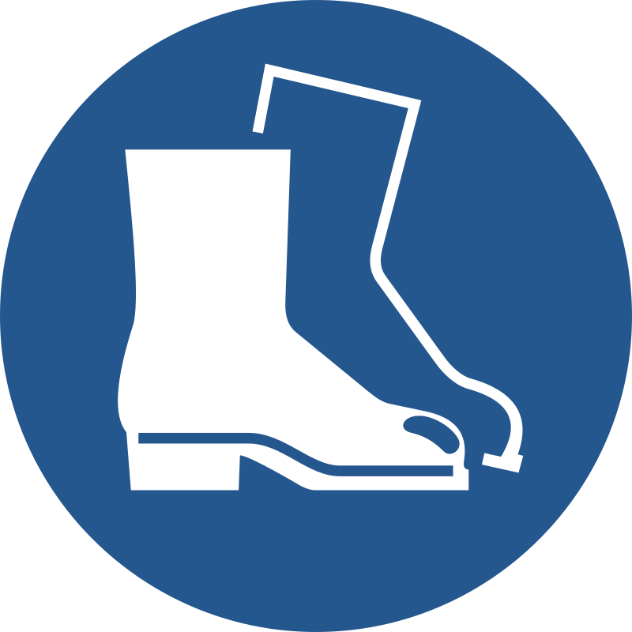
Hazards are present in this laboratory. Review list of hazards before entry.
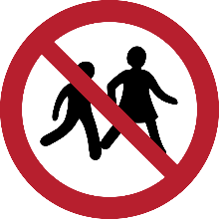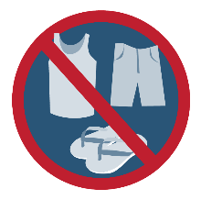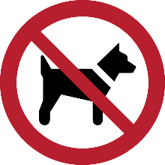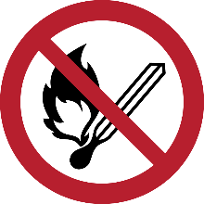
No Food or Drink Authorized Minors Only Proper Lab Attire Only Authorized Service No Open Flame
Animals Only

HAZARDS in Building, Room #
Consult Lab Safety Manual and Chemical Hygiene Plan for list of specific hazards.
Fire Hazards
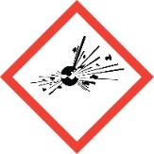
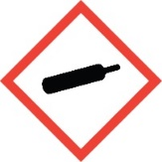
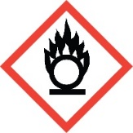
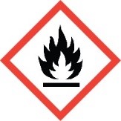
Oxidizers
Flammables
Pyrophorics
Self-heating
Emits Flammable Gas
Self-Reactives
Organic Peroxides
Gases under pressure
Explosives
Self-reactives
Organic Peroxides

Health Hazards
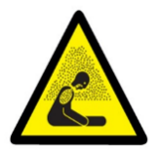
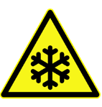
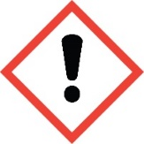
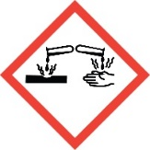
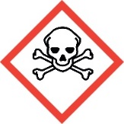
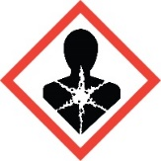
Asphyxiant (replaces oxygen in breathable air)
Cryogen (temperature way below freezing)
Irritant (skin and eye)
Skin sensitizer
Acute toxicity (harmful)
Narcotic effects
Respiratory tract irritant
Corrosive to skin/burns
Causes serious eye damage
Corrosive to metals
Acutely toxic (fatal or toxic)
Carcinogen
Mutagen
Reproductive toxin
Respiratory sensitizer
Toxic to target organs
Toxic by aspiration

Physical and Other Hazards
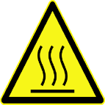
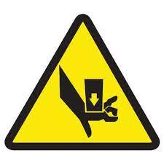
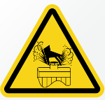

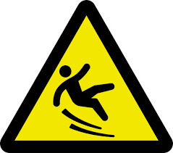
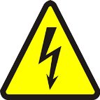

Hot
Steam
Cut
Slips/Trips/Falls
High voltage
Others
Pinch point
High pressure
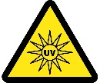
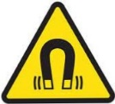
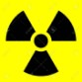
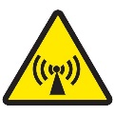
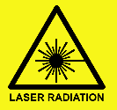
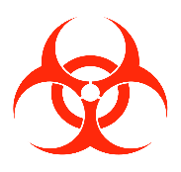
Crush
Non-ionizing radiation
(Radio frequency, Infrared, Microwave)
Strong magnet

X-ray
Ultraviolet light

Laser – Class
Isotopes (³H, ³²P, ³⁵S, ¹²⁵I)
Radiation Hazards

Biological Hazards
BSL-
Mold spores
Allergens
Human-derived materials
Lentivirus
Bacterial pathogens
Mosquitoes

