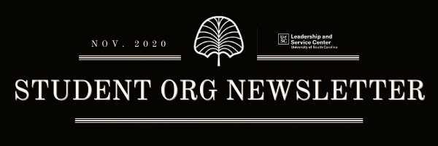

Hello Student Organization Leaders!
Below is the Student Organization Newsletter for the month of November. Please reach out to us at lsc@sc.edu or 803-777-7130 if you have any questions or if there is anything that you need.

Election Resources
We know this is a big week. We encourage you to vote tomorrow if you haven’t already. We are here to support you navigate this election with resilience as student leaders, so you can support your fellow students across campus.

Elections are a fundamental principle of democracy, and they signal potential change across society. For some, this signal brings excitement and optimism and for others the signal is stressful and causes anxiety. At UofSC we have opportunities for all individuals to engage and discuss what this year’s elections signal to them.

Student Org Activities Post-Thanksgiving
As we wrap up the semester, we just want to give a friendly reminder that student organizations are not allowed to have face-to-face activities or events after Nov. 27 in alignment with the fall university calendar readjustment. Also, please remember that student organizations are not to have any activities or events between Dec. 2-14. This is in place to ensure that students are focusing on their finals and academics. If you have questions about this university policy, please let us know.

Student Org Roundtable
This month’s Student Organization Roundtable will be Wednesday, Nov. 11 from 3-4 pm! The topic will be “Utilizing Your Team.” Register for the Roundtable on Garnet Gate or by using this link.

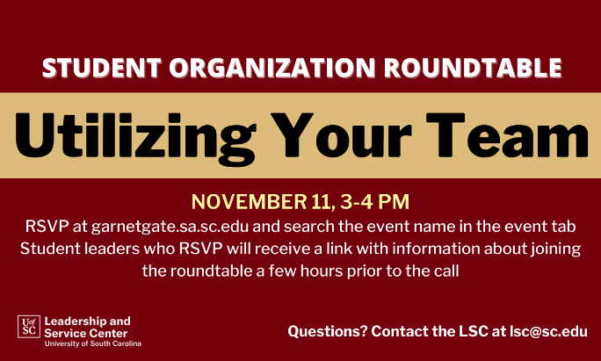

Garnet Gate Roster Update
Verified records of student organization memberships are collected in each student’s My UofSC Experience, a university platform which records the many experiences both for credit and not for credit that students engage in while at UofSC.

In order for your organization members to have their involvement included in My UofSC Experience, it is your responsibility as an organization to verify your roster is up to date for Fall 2020 and that it reflects your active membership. The accuracy and integrity of these student records is essential. Only records of membership that have been verified will be collected in My UofSC Experience.

Click here for a video showing how to complete this process through the manage portal in Garnet Gate.

No Title Needed
Have an outstanding member in your organization? No Title Needed in an initiative to highlight students across campus demonstrating leadership without a title or position. Use this link to nominate someone in your organization! Selected students will be featured on the Leadership and Service Center’s social media and receive prizes!

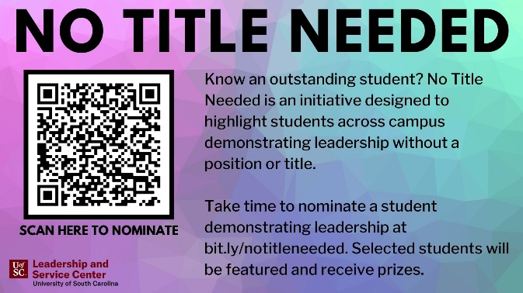

Funding Requests
We are currently accepting funding applications for Spring events! Student organizations may request funding for programming, virtual conferences, competitions, and tournaments using the Garnet Gate budget request. Organizations are encouraged to work with their Comptrollers as a resource throughout the allocation process. There is still time to plan awesome events for the Spring semester, get your requests in early!

Student Organization Resources
Looking for resources on how to lead your organization? Head over to the LSC’s website to view the Organization Toolbox to get resources on marketing, communication, event planning and more!
Service Saturday
Service Saturday is a monthly service day where volunteers can choose from a range of service sites. Consider organizing a group of members to engage together to further your relationships with each other while engaging with the Columbia community. Please register on the Service Saturday website. If you have any questions, contact Megan Michener in the Leadership and Service Center.

Russell House Underground
Is your organization looking for an event space that is edgy, modern, and has chill vibes? Fully equipped with high-quality audio and live streaming capabilities, Russell Underground is the perfect multipurpose venue that can take your student organization socials and events to the next level! Learn more information about the space by attending the open house on Nov. 10 or by learning more info at go.sc.edu/RussellUnderground

