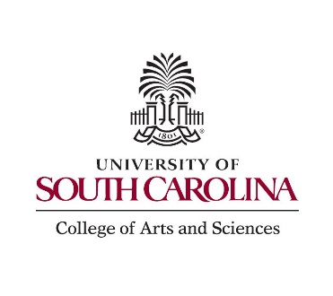

Fall 2026 Seminar Series

Date | Speaker (Institution) | Host (Division) | Account
August 18 | Classes begin
August 21
August 28 | ^{ACS 08/23-27} Department
September 2 | Eva Ge (UNC Charlotte) | Truex (Biochem)
September 4 | ^{Labor Day 09/07} Junfeng Chen (USC) | TPR
September 11 | Christian Johnson (USC) | TPR
September 18 | ^{Family weekend}  Kristie Boering (UC Berkley) | Wendell (DEPT)
September 24 | Bingchen Yu (Georgia State) | Q. Wang (Org)
September 25 | Piro Lito (MSKCC) | Johnson (DEPT)
October 2 | Ryan Richards (Colorado Mines) | Vannucci (DEPT)
October 9
October 12 | Mark Jones (ACS) | Richardson (Analyt)
October 16 | ^{Fall break 10/15-10/16}  Ted Betley (Harvard) Adams lecture | Adams (DEPT)
October 23 | Zdenek Dohnalek (PNNL) | Donna Chen (DEPT)
October 30 | David Morgan (MSU) | Qun Lu (DEPT)
November 6 | Chuck Henry (Colorado State U) | Simoska (DEPT)
November 13 | Sam Gellman (University of Wisconsin) | Truex (DEPT)
November 20 | Christine Thomas (Ohio State U) | HB Lee (DEPT)
November 27 | Thanksgiving break 11/22-11/29
December 4 | ^{Last day of classes} John Lavigne (USC) | Donna Chen (DEPT)
December 11 | Department
December 18 | Department (if needed)
All seminars will be held at 4:00 p.m. in JONES 006 unless otherwise indicated.
Refreshments served at 3:45 p.m.

