Quick Start Guide

Quick Start Guide

Digital Measures System Navigation & Features

Log in to Digital Measures: https://www.digitalmeasures.com/login/org-ghs/faculty

Navigating Activity Insight
The left-hand menu of the system displays at least three main menu tabs, Manage Activities, Rapid Reports and Run Reports. You may have other tabs if your Digital Measures Administrator has given you security access to them.

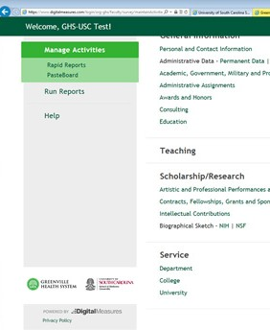
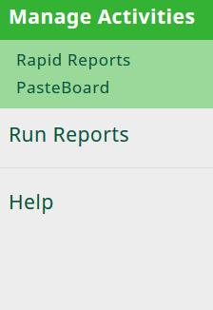
Manage Activities
Add or update information about the activities you accomplish.

Run
Custom Reports
Rapid Reports & Run Reports
Run reports that have been custom-built for your campus.
Use Rapid Reports for the quickest results.
Contact Help
Submit questions about use of the system submit suggestions on how to improve the system. Select your Digital Measures Administrator for system access, questions about the system, requests for changes to the system or additional reports, and corrections to Read-Only data.

Contact Help
Select HELP for system access, questions about the system,
Submit questions about use of the system submit suggestions on how to improve the system. Select your Digital Measures Administrator for system access, questions about the system, requests for changes to the system or additional reports, and
corrections to Read-Only data. Select Digital Measures for suggest system or feedback on the system in general.
requests for changes to the system or additional reports, and corrections to Read-Only data. Your questions and comments will be sent by email immediately to your Digital Measures Project Coordinator.
Select Digital Measures for suggestions on improving the tem in general.
system or feedback on the sys

Manage Activities
When you first visit this screen, it would be good to spend a few minutes looking through the screens accessible from it. To access a screen, click its name. The resulting screen displays records that are stored for that screen. There are three possible actions you can take from the
resulting screen, although not all of these actions will always be available: To add a new record, click the button.
To edit a record, click on the item.
To delete a record, click the button.

Three important notes about working on the Manage Activities tab…
1. Records marked with a small “R” beside them are Read-Only information. These records ha and cannot be edited except by your department’s key administrator, the DM Administrator or the Course Director. If these records need revision, contact your Administrator using the Hel

2. When working in the system, if you make changes and want to keep the changes, you need at the bottom of the screen prior to leaving it.
3. The screens available from the Manage Activities tab and all of the fields on them have bee
campus. These can still be changed in any way needed. To propose changes that you woul
Administrator using the Help link.

ions on improving the

Manage Activities
When you first visit this screen, it would be good to spend a few minutes looking through the screens accessible from it. To access a screen, click its name. The resulting screen displays records that are stored for that screen. There are three possible actions you can take from the
resulting screen, although not all of these actions will always be available: To add a new record, click the button.

ve been added to the system for you
, in cases of courses and modules, p link.

to click one of the Save buttons

n customized for your
d like to see made, contact your
To edit a record, click on the item.
To delete a record, click the button.

Save Records
When working in the system, if you make changes and want to keep the changes, you need to click one of the Save buttons
at the bottom of the screen prior to leaving it.
at the top of the screen prior to leaving it.

Search Box
Use the Search Box at the top of the screen to search for specific items you want to locate quickly, such as a publication entry, a presentation, a class you taught, or another specific item. Just use a key word and if the item is in the system, it will bring up the item and tell you on which screen it’s located.

Digital Measures System Navigation & Features

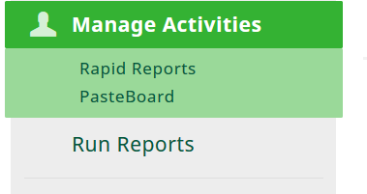
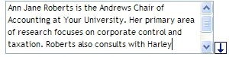
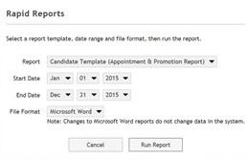
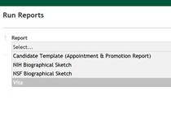
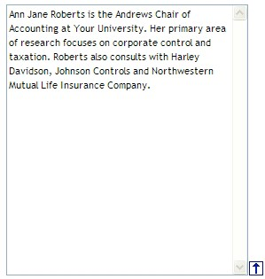
Expanding Text Boxes

Expanding Text Boxes
You may see a blue arrow next to or under text boxes. Clicking this blue arrow makes the text box next to it larger to give you more space.
You may see gray dots or black lines in text boxes. Clicking this area makes the text box next to it larger to give you more space.

Required Fields

Required Fields
Required ﬁelds are indicated by red asterisks, such as this: Academic Year *
Required fields are indicated by red asterisks, such as this: Academic Year *
Required fields are indicated by red circles, such as this: • Scope

Read-Only Fields
The PasteBoard
You will find the PasteBoard to be a time-saving feature. The PasteBoard allows you to copy text from another document, such as your vita in Microsoft Word, and paste it into the PasteBoard. After you have pasted text into the PasteBoard, you can then select text from it, click-and-hold on the text you selected, and drag the text into a field in the system to have it pasted into the field.

To access the PasteBoard, click the word PasteBoard in the upper/left side of the screen.
Read-only fields can be reviewed but can only be changed by the Digital Measures
System Administrator or your department’s key administrator.

Public Fields
Our Digital Measures Activity Insight System is not open to the public. Sometime in the future, certain fields from the Digital Measures System Personal and Contact Information Screen will be used to populate faculty profiles on the USC School of Medicine Greenville website. Fields that will be public at that time are marked with a red “P,” such as this: P First Name. Users will be notified before any information becomes public.

Run Custom Reports
This menu tab allows you to run reports that have been custom-built into the system
for your campus. To run a report, simply select from the steps on the page. Select the Rapid Reports option if you are managing data only for yourself. If you need to include others in your report, select the Run Reports option.

The reports that are available from step number one have been customized for
Required ﬁelds are indicated by red asterisks, such as this: Academic Year *

The PasteBoard
You will find the PasteBoard to be a time-saving feature. The PasteBoard allows you to copy text from another document, such as your vita in Microsoft Word, and paste it into the PasteBoard. After you have pasted text into the PasteBoard, you can then select text from it, click-and-hold on the text you selected, and drag the text into a field in the system to have it pasted into the field.

To access the PasteBoard, click the word PasteBoard in the upper/left side of the screen.

A common question… Does this system have a spell-check feature?
your campus. If you have suggestions on additional reports that should be added, please contact your Digital Measures Administrator using the Help link.

A common question… Does this system have a spell-check feature?
Digital Measures does not have a spell-check function, but you can open Microsoft Word,
Digital Measures does not have a spell-check function, but you can open Microsoft Word, put in the text you want to check, and use the Spell Check function there.

put in the text you want to check, and use the Spell Check function there.

