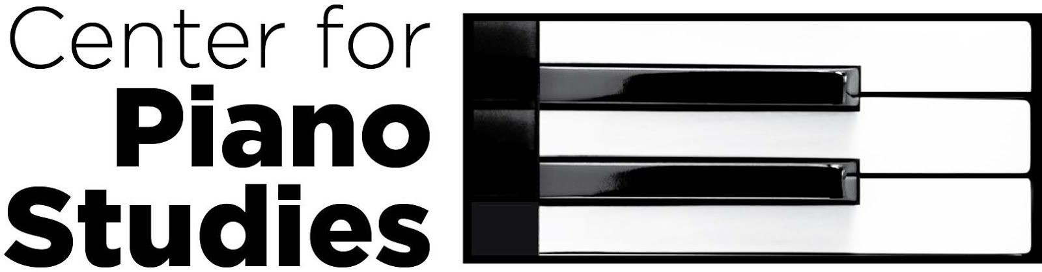
at the USC School of Music

USC Students, Adult Musician & Artist Program Masterclasses

Recital Hall, Room 206
Saturday, November 9, 9:30–11:00 a.m.
Sunday, March 29, 2:30-4:00 p.m.

Events Calendar

Fall Festival for Young Pianists October 19, 9:30 a.m.-12:00 p.m. School of Music December Adult Recital December 8 School of Music
Royal Conservatory Exams* December TBD School of Music Celebration of Musical Achievements March TBD TBD
Spring Recitals May 2-3 School of Music
Royal Conservatory Exams* May TBD School of Music

*Optional: At additional charge for adult students.

Contact Information
Director, Dr. Sara Ernst sernst@mozart.sc.edu 777-1688
Administrative Assistant piano@mozart.sc.edu 777-4414
School of Music Main Office 777-4280 & 777-4281 813 Assembly Street
Columbia, SC 29208

sc.edu/music/community/piano
Website Calendar Policies Register & Tuition

