Compliance in mCE

In myClinicalExchange, there are four types of compliance for you to enter. Which parts of this you need to complete will depend on the hospital you rotate at. Some hospitals use all four compliance areas, while some use only some of these. Our four types of compliance are checklists, documents, modules, and exams.

Once you have been scheduled to a rotation, you receive all compliance requirements for that rotation. You can only complete documents, modules, and exams after you have been scheduled to a rotation, which is usually something your school coordinator must do for you.

Before being scheduled, you have access to the Campus Compliance Checklist at the top of your screen. You can fill this out in advance if you would like, and this is the place where you normally enter your checklist information.

mCE has two types of checklists, campus checklists and hospital checklists. Most hospital checklists do not allow you to edit them. So you will normally just fill out your campus checklist, and then submit it to your coordinator for review.

In some cases, your campus checklist could contain items that you do not need to fill out unless you are going to a specific hospital. You can check with your school coordinator for clarification.

If you choose to fill out the campus checklist before being assigned to a rotation, it can give you a head start on your compliance.

This help file gives you basic instructions for completing your campus checklist, documents, modules, and exams to help you become compliant for your rotations.

If you are not yet scheduled to a rotation, you can check with your school coordinator about when you will be scheduled to one.

Campus Compliance Checklist

To edit the campus checklist, just click Campus Compliance Checklist at the top of your homepage.
This brings up the actual checklist for you, as the screenshot below demonstrates.
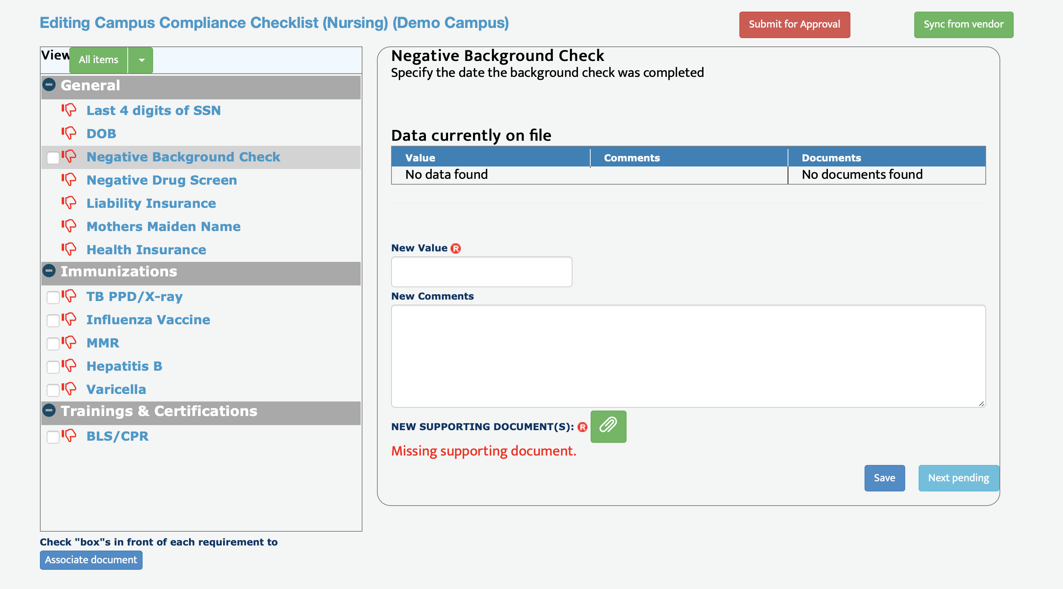
On the left, you seem item names with red thumbs down to indicate items that are out of compliance.

As you click on the item names, you will see item descriptions with instructions on what you need. You will also see a value field. The value field always needs information and can never be left blank. Comments are optional.

If an item is missing a document and needs one, you will see red text at the bottom that says, “Missing supporting document.” Simply click the green paperclip to add the document.

After you enter information, click Save. You can then either navigate to other items to enter on the left, or you can click “Next pending” on the bottom right to advance to the next item you need to complete.

You can associate a document to multiple items by using the column on the left. Just check mark the items you want to link the document to on the left side, and then click “Associate Document” at the bottom.

Once you have either completed all items on the checklist or have entered everything you need to send for review, click the red Submit for Approval button on the top right.

Once you submit your checklist, it locks for review by your coordinator. You will not be able to edit it until that person does their review for you. Please contact your coordinator if you are stuck waiting for their review.
Documents

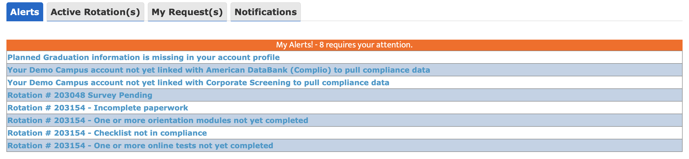
If you need to complete compliance for the Documents area, you will have an alert in the Alerts section of your homepage about “Incomplete paperwork”.
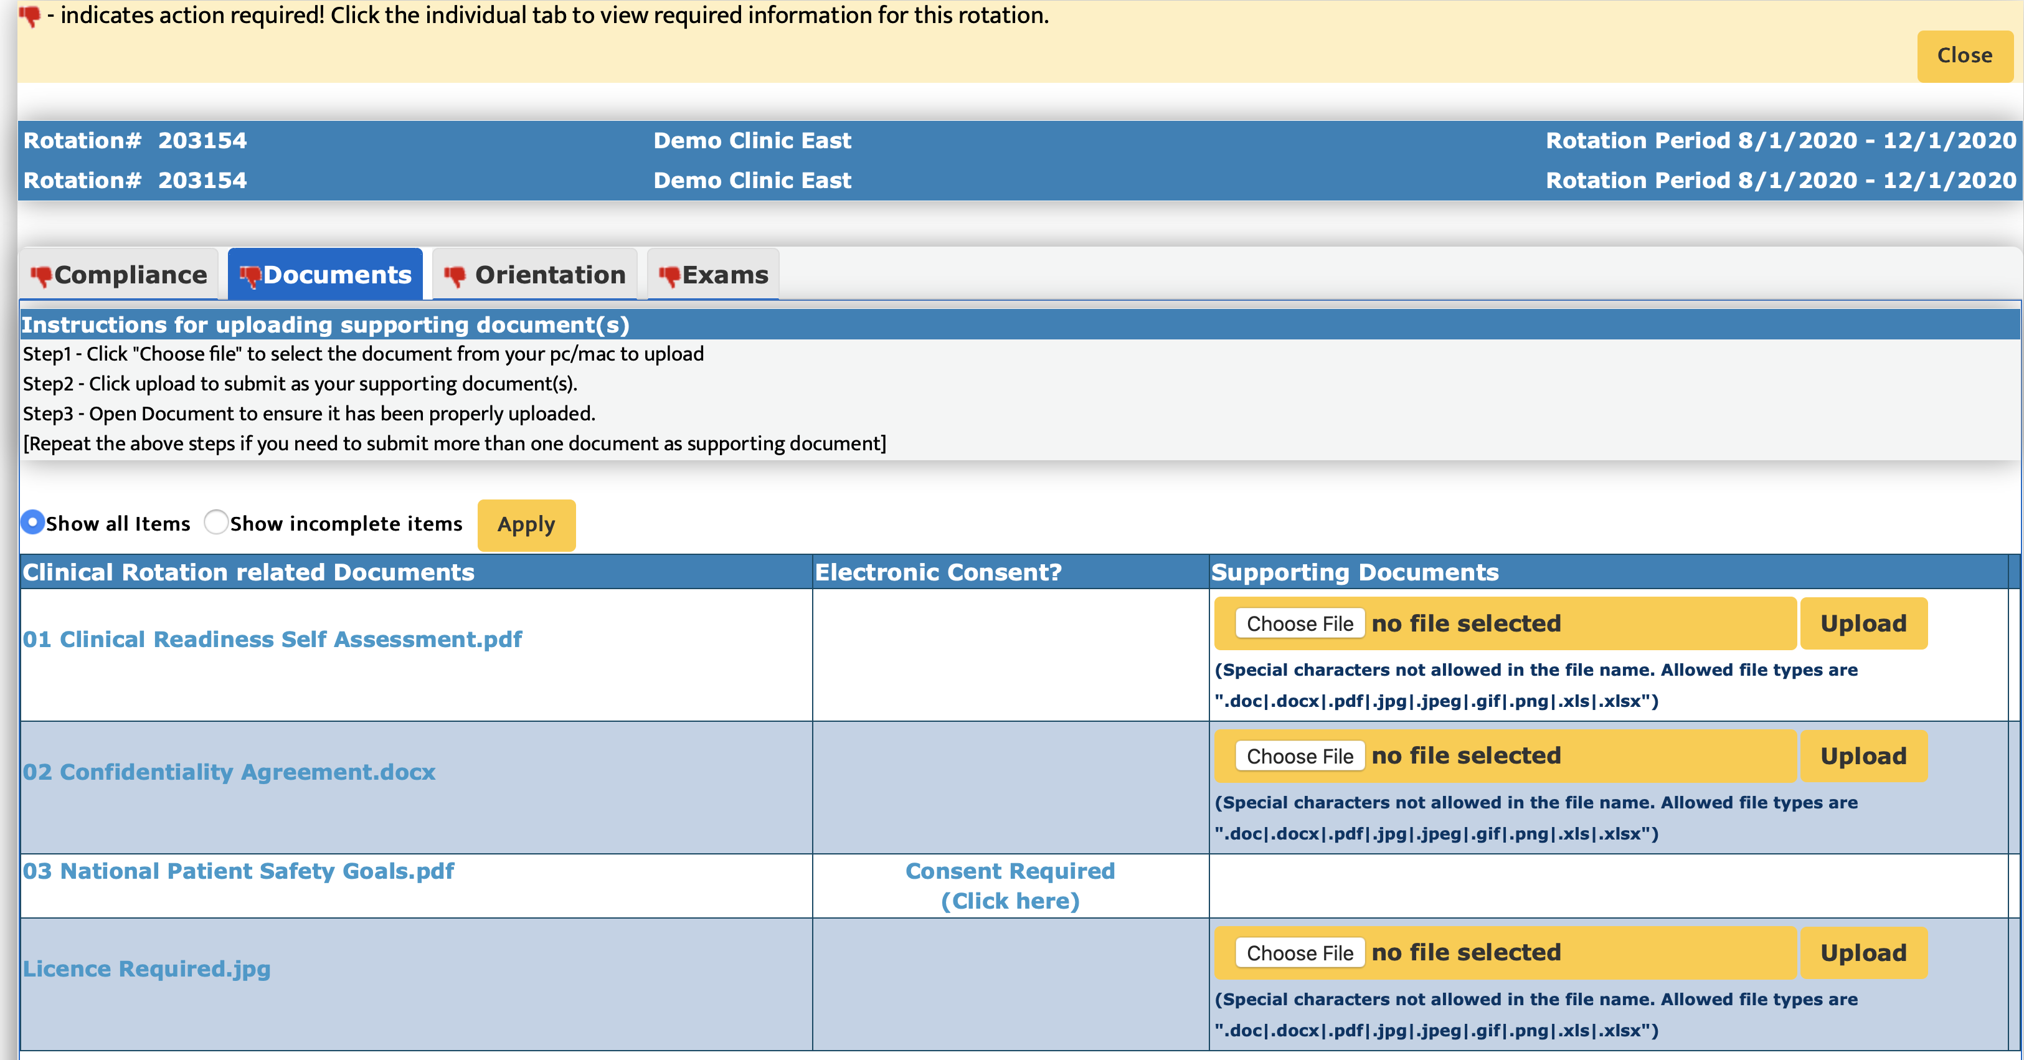
The Documents area of your rotation is a place for hospitals to provide you with informational documents you can read or download and also a compliance area where you sometimes must enter an electronic consent or upload a document. You can click the “Incomplete paperwork” alert to go to the Documents area.
If it says Consent Required next to an item, you simply click Consent Required, and then click “I agree” to register your compliance.

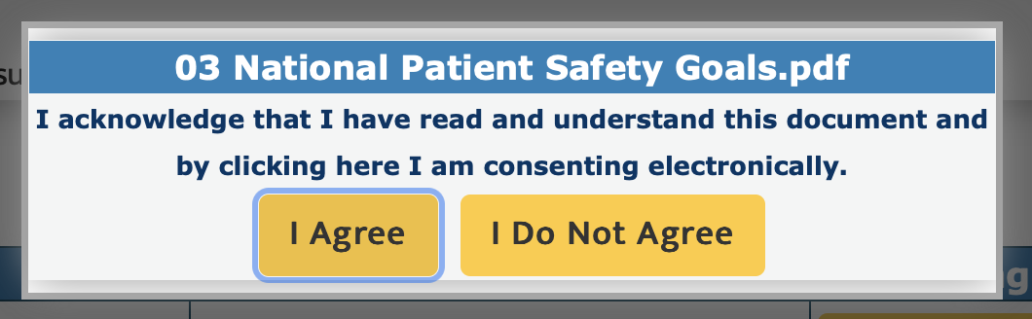

Then it will show your consent. Your consent cannot be withdrawn.
If the Supporting Documents tab shows a document upload area for an item, and there has been no document uploaded, then you must upload one to be compliant. Just click Choose File to select your document. Then click Upload to store the item in mCE. The document appears in blue, letting you know you completed that item.

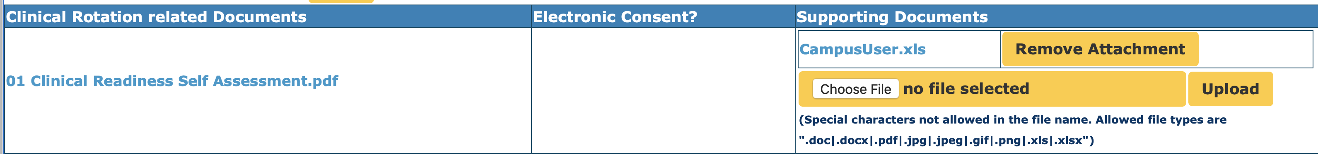
At the top of the Documents area, you will see a red thumb when you are out of compliance.
Once you complete all items, the red thumbs down will become a green thumbs up. You can also click through all the tabs to go to other areas of your compliance for you to complete. Once all tabs have a green thumb, or at least have no more red thumbs (in case a section is not being used), your rotation is cleared for compliance in mCE. You would tell your coordinator you completed everything, and your coordinator should check with the hospital to see if they have anything else for you outside of mCE.

Orientation

The Orientation section contains modules for you to watch. These are slide shows that you view and click through. If your rotation has a module for you to complete, you will see an alert about orientation modules.
Clicking the alert takes you to the Orientation area.
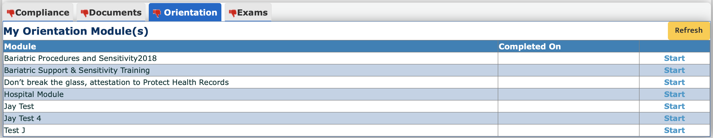
You click start to begin the module. Simply click Next until you reach the end, and then you must click the yellow Finish button at the end to complete the module.

Exams

If you have Exams to complete, you will have an alert about online tests.
Clicking this alert brings you to the Exams area.
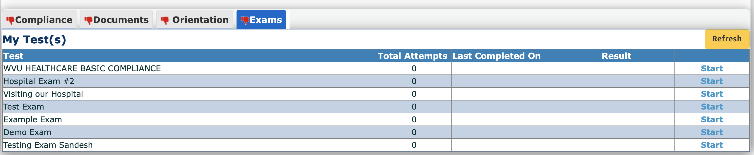
Click Start to begin the exam. Once you start, an attempt will be registered. Most exams have instructions at the beginning. Some are set to a limited number of attempts, and all require a certain passing score that is determined by the hospital. If you run out of attempts to take the exam, only the hospital can approve mCE to reset it for one more attempt. So prepare well before you take an exam.
My Rotations
Clicking My Rotations at the top of your screen brings you to a useful area where you can see your rotations.
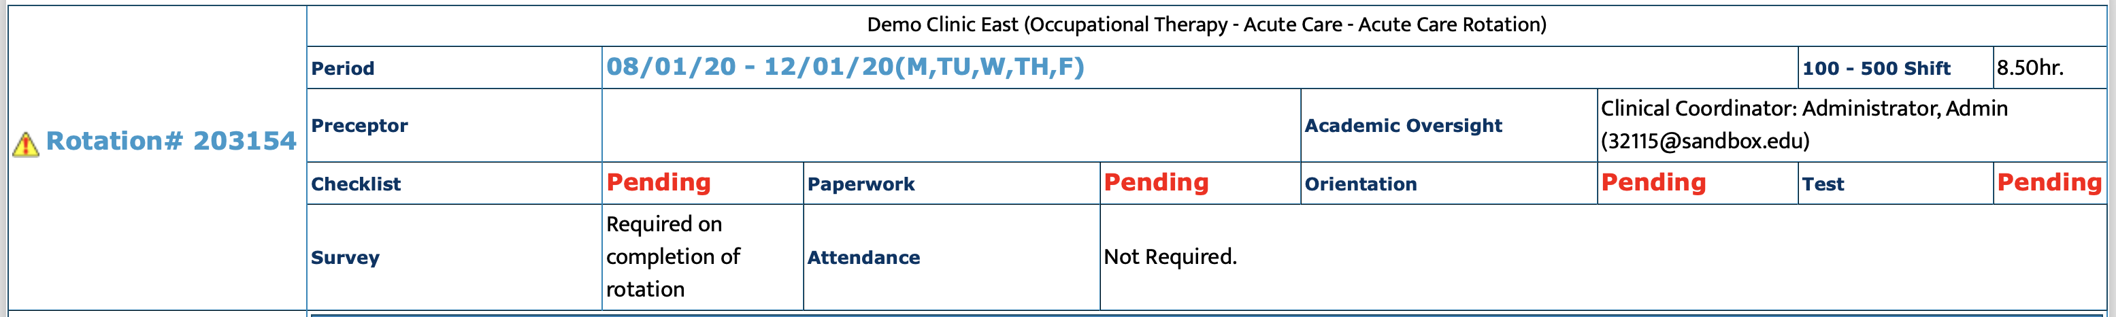
You can find the rotation you need, and then click on the red word Pending next to any of the compliance areas to go directly to that compliance tab (or a green Completed if you already finished that compliance tab).

Clicking next to checklist takes you to the hospital checklist instead of the campus one. Usually, you will not be able to edit a hospital checklist and should only view that for informational purposes unless instructed otherwise. Your checklist edits should instead be done on your homepage in the Campus Compliance Checklist described at the beginning of this document.

Troubleshooting

Please always use mCE only on a desktop or laptop with Firefox, Chrome, or Safari as your browser. We are not compatible on mobile devices. Clear your cache if you have a problem. If the problem continues or you need more help, contact us: support@myclinicalexchange.com

