The Non-Employee Identity Suite (NEIS) is used to store identifier information for our students/faculty. It is also used to allow the students/faculty to claim their account by validating their personal information. This is a one-time assertion. There is no need for additional authentications into the NEIS by students/faculty. Any changes to identifier information should come be reported to studentprograms@novanthealth.org.
Once the students/faculty have claimed their identity, the onboarding workflow will generate a CorpID and initiate the password registration in the new OneIM solution. On their start date application access will be applied, if applicable.
- A “Novant Health Account Claiming Invitation” email will be sent to your personal email. This will prompt you to claim your identity. In NEIS, you must setup a local password that will only be utilized this one time. You will be prompted to enter your personal information (First Name; Last Name; Last 4 SSN; Birth Month; Birth Day).
  - There is potential for the NEIS email to be treated as SPAM; reassigned to a trash/junk folder.
  - Portal URL link is only valid for 14-days to claim your identity. If after 2 weeks contact studentprograms@novanthealth.org.
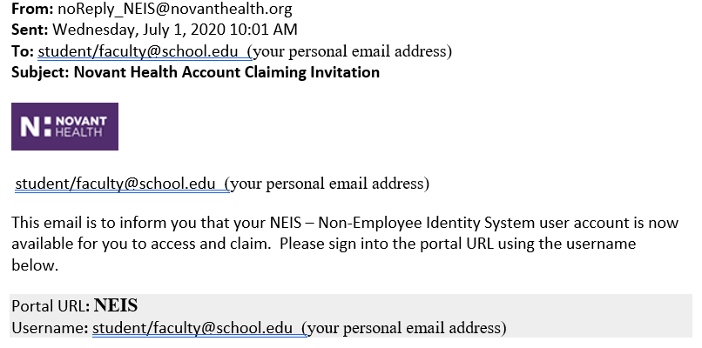

- In the email, click on the Portal URL link.
- The NEIS Account Activation page will open on your device browser.
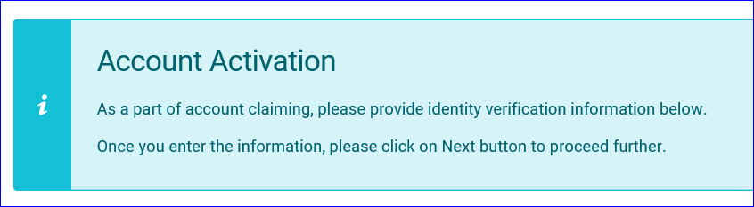
- Complete the following fields with your information:
  - First name – enter your legal first name
  - Last name – enter your legal last name
  - Birth month – click in the -Select- field and select your birth month value from the drop-down
  - Birth day – click in the -Select- field and select your birth day value from the
  - drop-down
  - Select last 4 of SSN attribute (nhlast4ssn) from dropdown – click on the field and select nhlast4ssn
  - Last 4 of SSN – Enter last 4 digits of your SSN

- Click on the Next button on the lower right of this page. The NEIS Account Activation password page will display. Create your one-time NEIS password.
- Must be at least 8 characters long
- Must contain 1 special character
- May not be a Dictionary word

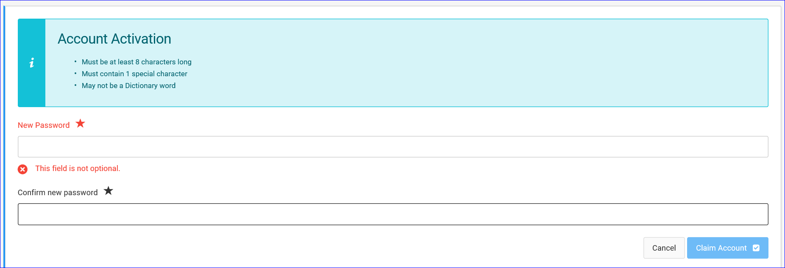
- Enter New Password
- Confirm new password
- Click on the Claim Account button on the lower right of this page.
- The Account Activation – Congratulations page displays with your User ID
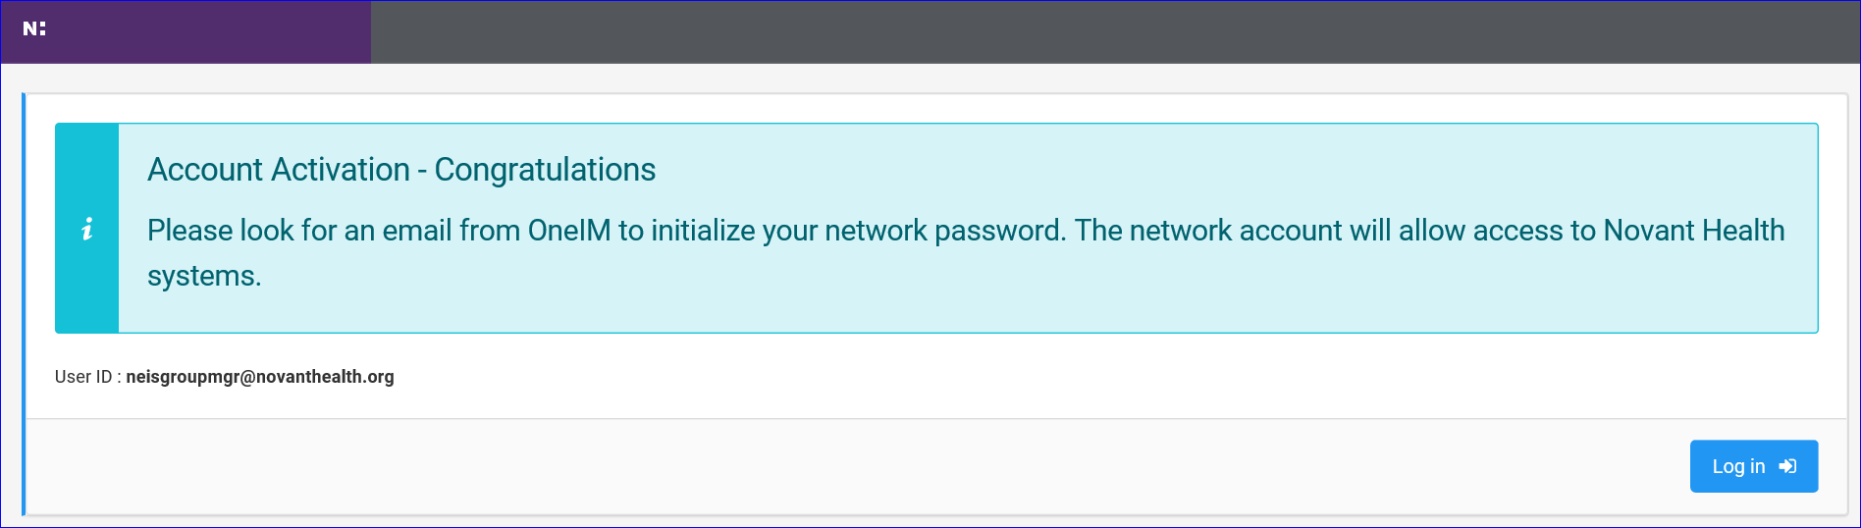

- Click on the Log in button on the lower right of this page.
- Once NEIS account is claimed, you will receive the “Your account is successfully claimed” email.
  - This “Successfully Claimed” email is only sent to the student/faculty.
  - Potential for NEIS email to be treated as SPAM; reassigned to a trash/junk folder.
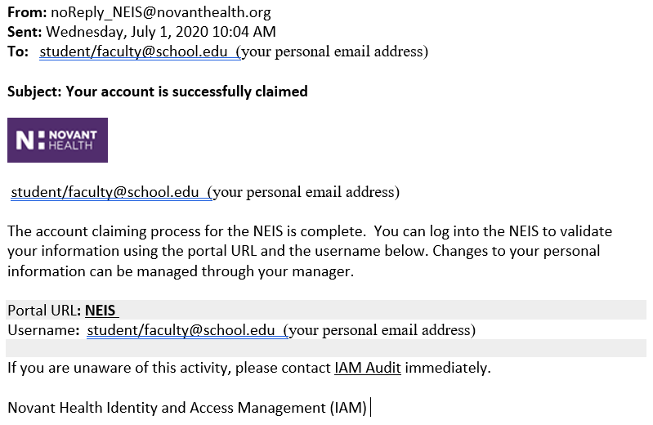

- Within 24 hours, you will receive the "Begin MyPassword registration” email. This email will include your Novant Health CorpID.

    - Click on the URL link on the "Begin MyPassword registration” email. (https://secure.novanthealth.org/)
    - The Novant Health Password Manager Portal screen will display on your device. Enter:
      - Username: stuser
      - Password: ST3892D
This will be used to securely authenticate and direct you to the Novant Health Password Manager screen.
    - On the Novant Health Password Manager screen, enter your username (CorpID) found on the "Begin MyPassword registration” email.
    - On the Password Manager Home page, click on the Account Activation link.
    - Continue to follow prompts on the screen to complete your verification and registration for MyPassword.
      - The password created during password registration will be used to authenticate to the Novant Health network and is valid for the next 90 days.

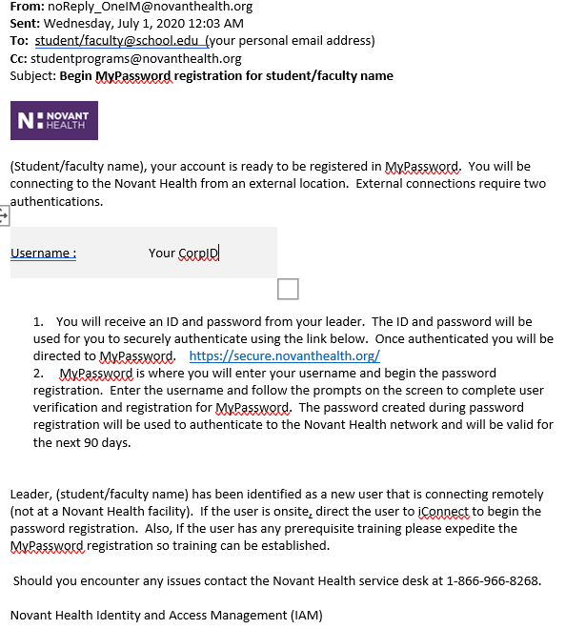

- Once you have completed the MyPassword Registration process, you will receive the “MyPassword registration complete” email.
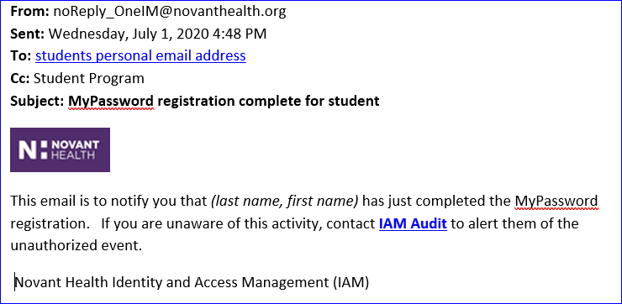
- As part of the Novant Health onboarding process, you will also receive the “Start date for” email. No further action is required at this time.

