Online Orientation & Participation Agreement
(Completed by Student)

- Go to the following link: https://www.rsfh.com/orientation/main.aspx
The page will look like this –
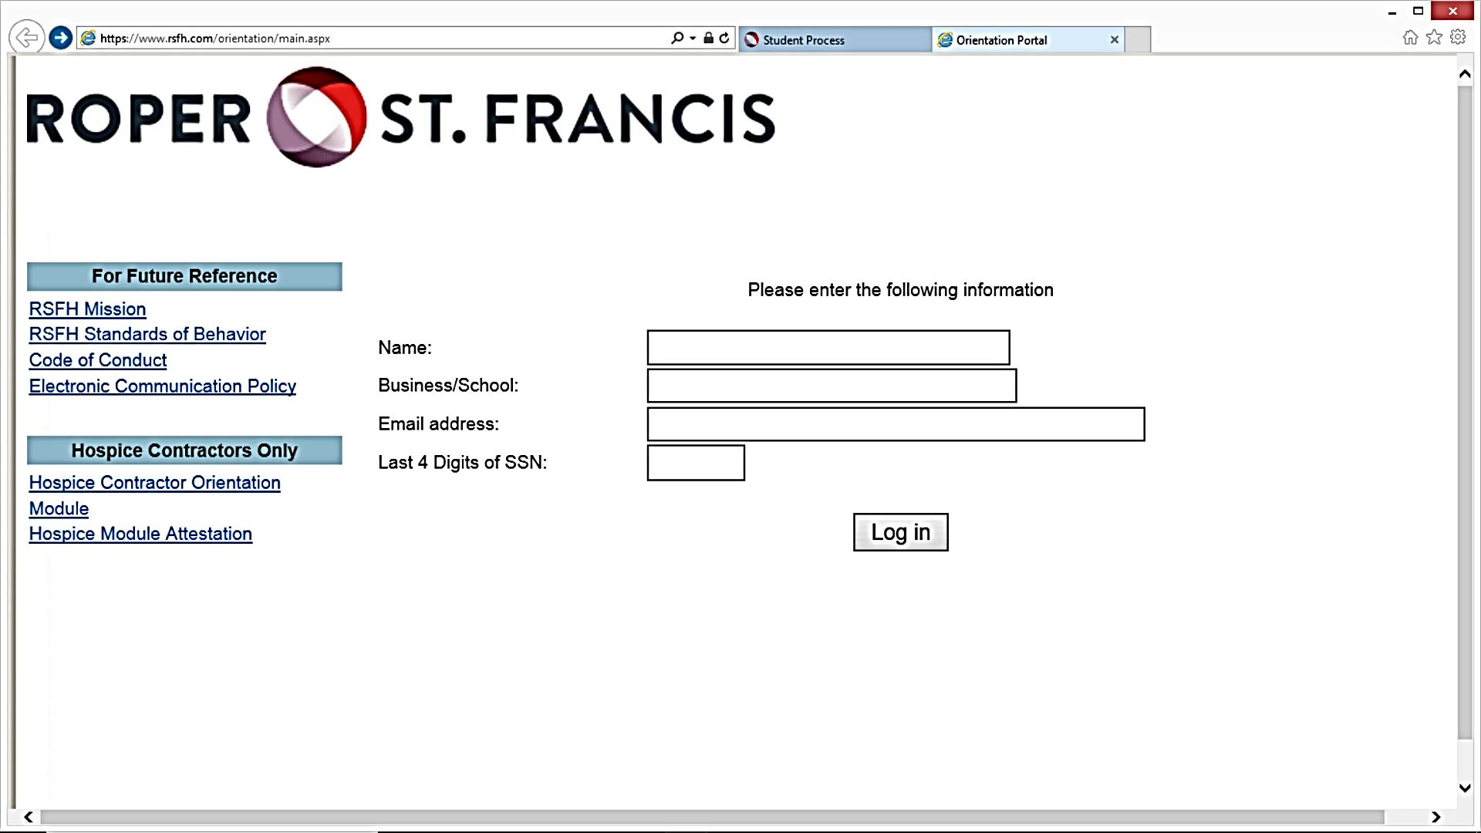
- Enter Name, School, Email Address, and Last 4 Digits of SSN
- Click “Log In”
- Click on “Orientation Module”
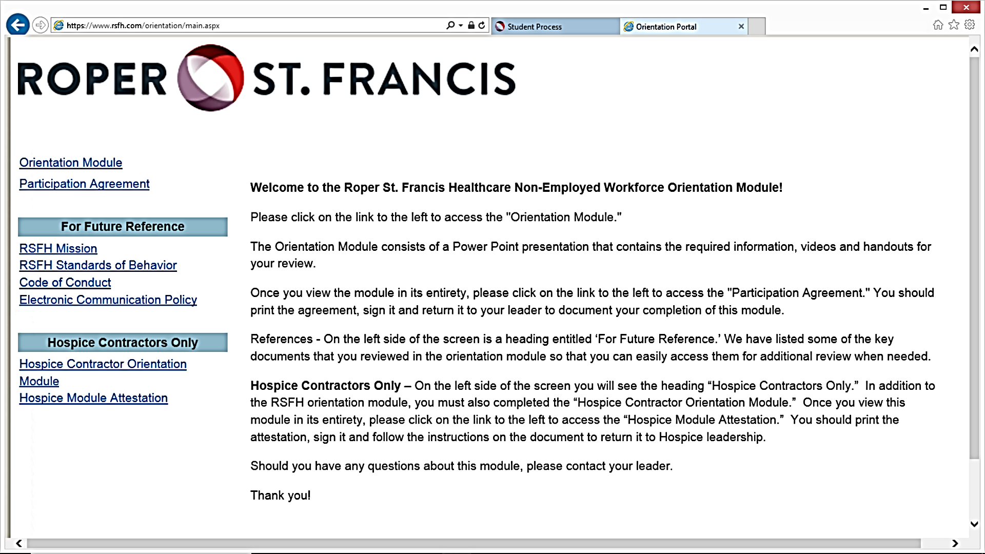
- Read through the slides carefully. There are 88 slides.
- When you are finished, close the slides page. Click on “Participation Agreement.”
- Print, Date, and Sign p. 3 of the Participation Agreement (PA).
- Submit the signed PA to your school/residency/fellowship coordinator or student.development@rsfh.com
NOTE: RSFH will audit Online Orientation submissions for completion.

