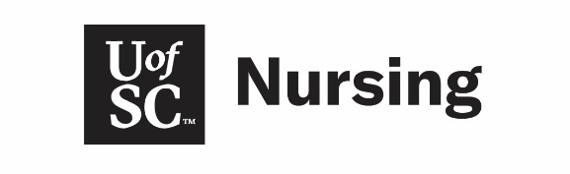

Study Abroad Contract
Nursing students who are interested in studying abroad during a spring semester should start planning early. The BSN degree requires courses to be taken in a specific progression. To maintain eligibility to apply for upper division and study abroad during a major semester the following steps must be completed.
Required steps to the study abroad process:
- Attend an information session with the Study Abroad Office – make appointment in Navigate or through the Study Abroad Office website.
- Email your Academic Advisor to indicate interest in semester study abroad.
- Complete College of Nursing Study Abroad Contract.
- Meet with the College of Nursing’s study abroad liaison – Marci Heidt. You can contact her at mmheidt@email.sc.edu or schedule a meeting at http://sc.campus.eab.com/
- Meet with nursing advisor for signed college approval for the specific program chosen – Deadline September 1.
- Submit courses for college approval – Deadline September 15.
- Apply for Study Abroad experience through Study Abroad Office (according to deadlines)
- Pre-departure meeting with nursing advisor in the December prior to studying abroad

Notes – When choosing a study abroad program be mindful of the semester timeline. For example, many universities in Australia end their spring semester in June whereas USC ends in early May. Some programs may be better suited for the time constraints of College of Nursing students and their upper division deadlines. Additionally, keep in mind that other steps may be required by the Study Abroad Office prior to your abroad experience.
Initial next to the following statements to acknowledge understanding.
______ Regardless of start date, I will choose a study abroad experience that allows me to return to start upper division classes the Monday following spring commencement.
______ I am aware that it is mandatory for health information to be submitted two weeks prior to the start of upper division coursework and nursing supplies (see BSN Undergraduate Handbook) be in-hand on the first day of classes.
______ I am aware that the College of Nursing cannot alter placement for fall or summer start of upper division based on study abroad plan.
______ I understand that I will need to complete NURS 220 online through USC-Columbia for my study abroad experience to have no impact on upper division eligibility.
______ I understand that if Carolina Core is not completed abroad, it is my responsibility to complete these requirements prior to graduation and ideally before starting upper division.
Student’s Name Printed: ____________________________ USC ID: _________________
Signature of Student: ________________________________ Date: ________________
Signature of Study Abroad Advisor: _____________________ Date: ________________
Signature of Nursing Advisor: __________________________ Date: ________________
Signature of Assistant Dean: ___________________________ Date: ________________

