

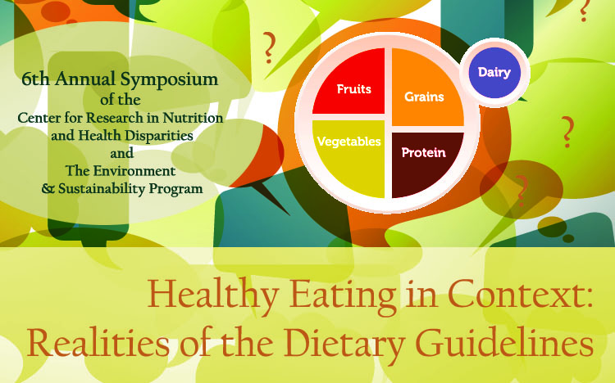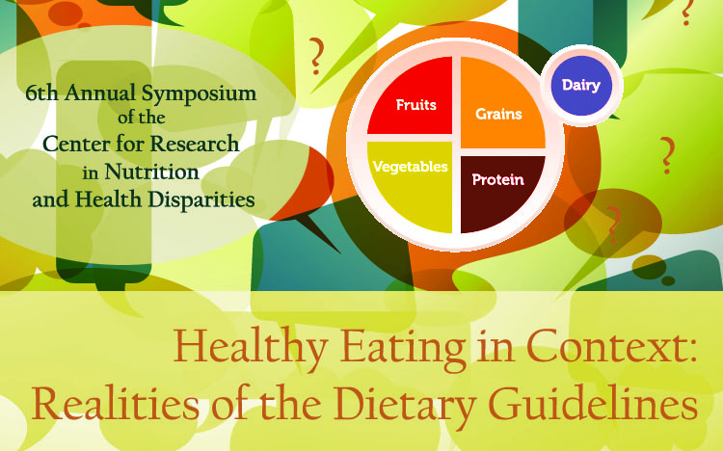

***The Center for Research in Nutrition and Health Disparities, and the Environment & Sustainability Program, Presents:***

Friday, March 18, 2016

8:30am- 1:30pm- Symposium

Carolina Alumni Center

## **Keynote Speaker:**

**Paul Cienfuegos**

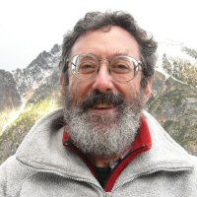

Workshop Leader, Lecturer, Writer, Bookseller, Engaged Citizen

## **Keynote Address**

## **“Why do large corporations get to decide what**

## **We the People eat?”**



# Agenda

8:30 — 9:00 **Registration, Light Refreshments**

9:00 — 9:10 **Welcoming Remarks**

Sonya Jones, PhD

Director, Center for Research in Nutrition and Health Disparities

Associate Professor, Department of Health Promotion, Education, and Behavior

Arnold School of Public Health

University of South Carolina

Gwendelyn Geidel, PhD, JD

Director, Environment & Sustainability Program

Research Professor, School of the Earth, Ocean, and Environment

College of Arts and Sciences

University of South Carolina

9:10 —10:40 **Keynote Address: “Why do large corporations get to decide what We the People eat?**

**Speaker Bio: Paul Cienfuegos** is a leader in the Community Rights movement, which works to dismantle corporate constitutional so-called “rights” and assert the people's inherent right to govern themselves. He has been leading workshops and giving public talks across the US since 1995 when he founded Democracy Unlimited in northern California. Paul moved to Portland, Oregon in 2011, co-founded Community Rights PDX in 2012, and helped to launch the Oregon Community Rights Network in 2013. David Barsamian's internationally syndicated show ‘Alternative Radio’ has broadcast five of his speeches. Paul produces a weekly radio commentary & podcast <[CommunityRightsPDX.org/podcast](http://communityrightspdx.org/podcast/)>, that any station can broadcast at no charge. He also produces a national 'Community Rights Update' newsletter with the latest news and analysis on the Community Rights movement, with more than 1200 subscribers. More info at [PaulCienfuegos.com](http://paulcienfuegos.com/). And starting in late February 2016, check out his newest project in collaboration with other movement leaders - Community Rights GroundWork - a national Community Rights support network for local groups.

10:40 —10:50 **Break**

10:50 —11:50 **Session I: Helping Communities Understand Dietary Guidelines and How to Meet Them**

Facilitator Christine E. Blake, PhD, RD

Assistant Professor

Department of Health Promotion, Education and Behavior

Arnold School of Public Health

University of South Carolina

Angela D. Liese, PhD, MPH

Professor, Department of Epidemiology and Biostatistics

Arnold School of Public Health

University of South Carolina

“The Dietary Patterns Methods Project: Key findings to date and new challenges relevant to dietary guidance”

Elizabeth Racine, DrPH, RD

Associate Professor, Health Sciences

College of Health & Human Services

University of North Carolina Charlotte

“Where’s the Problem: A Case for Targeted Interventions”

Trisha Mandes, MS, MPHN

Director, Columbia’s Cooking

Lead Nutritionist, IMAGINE STUDY

Cancer Prevention and Control Program

Arnold School of Public Health

University of South Carolina

“What in the World is a Whole Grain and How to Eat Them”

11:50 —12:15 **Lunch is Served**

12:15 —1:15 **Session II (over lunch): Diversity in Diet vs. Diversity in Agriculture**

Facilitator Gwendelyn Geidel, PhD, JD

Director, Environment & Sustainability Program

Research Professor, School of the Earth, Ocean, and Environment

College of Arts and Sciences

University of South Carolina

Anwar Merchant, ScD, MPH, DMD

Professor, Department of Epidemiology and Biostatistics

Director, Curriculum Development

Arnold School of Public Health

University of South Carolina

“Fat or Low-fat?”

Sonya Jones, PhD

Director, Center for Research in Nutrition and Health Disparities

Associate Professor, Department of Health Promotion Education and Behavior

Arnold School of Public Health

University of South Carolina

“Experiences Creating Food Systems Change”

Marie Stallworth

Director of Public Policy, Sustainable Midlands

Co-Founder, Midlands Food Alliance

“Bridging the Gap, Consumers and Producers”

1:15 —1:20 **Announcements**

Mary Wilson, MPH

Director of Capacity Building

Center for Research in Nutrition and Health Disparities

Arnold School of Public Health

University of South Carolina

1:20 —1:30 **Closing Remarks**

**6th Annual Nutrition Symposium Planning Committee**

**Sonya Jones, PhD**

**Director**

Center for Research in Nutrition and Health Disparities

Associate Professor, Department of Health Promotion, Education, and Behavior

Arnold School of Public Health

University of South Carolina

**Chairperson**

**Mary Wilson, MPH**

**Director of Capacity Building**

Center for Research in Nutrition and Health Disparities

Arnold School of Public Health

University of South Carolina

**Co-Chairperson**

**Ranina Outing, MHA**

**Director of Communications**

Center for Research in Nutrition and Health Disparities

Arnold School of Public Health

University of South Carolina

**Planning Committee Members**

**Arnold School of Public Health**

**University of South Carolina**

**Christine E. Blake, PhD, RD**

Assistant Professor, Department of Health Promotion, Education and Behavior

**Rachel Davis, PhD**

Assistant Professor, Department of Health Promotion, Education, and Behavior

**Gwendelyn Geidel, PhD, JD**

Director, Environment & Sustainability Program

Research Professor, School of the Earth, Ocean, and Environment

**Angela Liese**

Professor, Department of Epidemiology and Biostatistics

**Holly Pope, PhD**

Director of Evaluation, Center for Research in Nutrition and Health Disparities

**Wendy McKenzie**

Business Manager, Center for Research in Nutrition and Health Disparities, USC

**Anwar Merchant, ScD, MPH, DMD**

Associate Professor, Department of Epidemiology and Biostatistics

**Spencer Moore, PhD**

Associate Professor, Department of Health Promotion, Education, and Behavior

**Gabrielle Turner-McGrievy, PhD, RD**

Assistant Professor, Department of Health Promotion, Education, and Behavior

**A Very Special Thank You**

**Arnold School of Public Health**

**University of South Carolina**

**Jason Craig, PhD Student**

Department of Health Promotion, Education, and Behavior

Graduate Research Assistant, Center for Research in Nutrition and Health Disparities

**Carrie Draper, MSW**

Director of Policy & Partnership Development, Center for Research in Nutrition and Health Disparities

**James Hibbert, MS**

Geographer, Center for Research in Nutrition and Health Disparities

**Haley Littlejohn**

Work Study Student, Center for Research in Nutrition and Health Disparities

**Ashley Page, MSW**

Community Organizer, Center for Research in Nutrition and Health Disparities

**Katie Welborn**

Community Organizer, Center for Research in Nutrition and Health Disparities

**LeTanya Williams**

Community Organizer, Center for Research in Nutrition and Health Disparities

**Nick Younginer, PhD Student**

Department of Health Promotion, Education, and Behavior

Graduate Research Asst., Center for Research in Nutrition and Health Disparities

**SPONSORED BY:**

C:\Users\outingr\AppData\Local\Microsoft\Windows\Temporary Internet Files\Content.Word\Logo for ASPH Nutrition.eps



