A Seminar Presented by:

Ronald David Pate, Ph.D.

Adjunct Professor

Department of Sociology, Union University (Jackson Tennessee)
Getting to Good by Grounding Community Health
& Development in Stories
“What is Good?” is the question that Getting to Good in community health and development begins with. The only real way to answer this question is through a broad attentiveness to multiple stories. Dr. Pate will describe how this process of listening to, telling, and responding to stories:
- forms a learning community;
- enables deep understanding;
- values multiple heritages;
- catalyzes vision that energizes action; and
- facilitates solutions indirectly or obliquely.
Friday, April 24, 2015
1:30 PM – 2:30 PM
Discovery I, Room 140

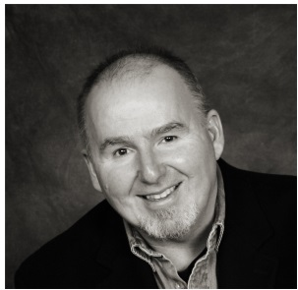
Dr. Ronald David Pate is an adjunct faculty member in the department of sociology at Union University and affiliated with Community Performance International - an innovative community building organization. Dr. Pate has facilitated a number of community formation and development processes, including: Woodlawn Stories; West Homewood Farmers Market; and West Homewood Community Exchange (in Alabama).

This is a free seminar and all faculty, staff, students, and guests are welcome to attend.

Contact Mary Wilson or Ranina Outing at nutrinfo@mailbox.sc.edu
or 803-777-6363 for more information http://nutritioncenter.sph.sc.edu/

